Trinette Anita Scott
July 3, 1969 – September 28, 2018

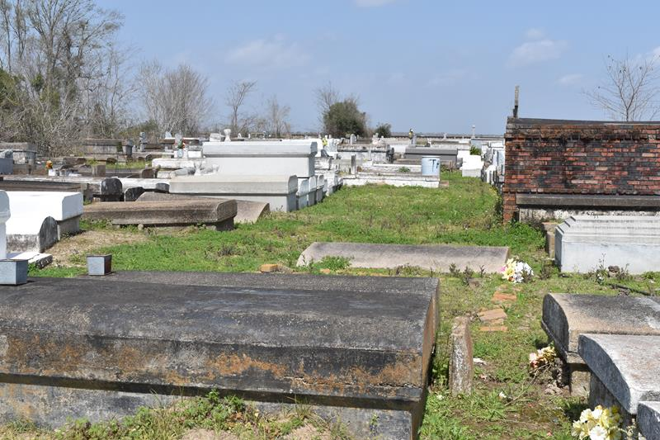

A NATIVE AND RESIDENT OF LUTCHER. SHE PASSED AWAY AT 5:44 A. M., FRIDAY, SEPTEMBER 28, 2018 AT ST. JAMES PARISH HOSPITAL IN LUTCHER. SHE WAS 49.
VISITING AT KING SOLOMON BAPTIST CHURCH, NORTH COURSEAULT STREET IN LUTCHER, FRIDAY, OCTOBER 5, 2018 FROM 9:30 A. M. UNTIL RELIGIOUS SERVICES AT 11:00 A. M. ONLY, CONDUCTED BY PASTOR ROWDY SCOTT. INTERMENT IN ANTIOCH BAPTIST CHURCH CEMETERY IN PAULINA.
SURVIVED BY HER SON, TYREN JAKE FLEMING. HER SISTERS: CHARLOTTE MELANCON (VINCENT), DELAWN LAWRENCE AND SHELIKA SCOTT. ALSO SURVIVED BY NUMEROUS AUNTS, UNCLES, NEICES, NEPHEWS, COUSINS, OTHER RELATIVES AND FRIENDS.
PRECEDED IN DEATH BY HER PARENTS: JAKE SCOTT AND MARY LEE MELANCON SCOTT. HER SISTER: CONSTANCE VALLERY AND HER MATERNAL AND PATERNAL GRANDPARENTS.

Brazier-Watson Funeral Home, Donaldsonville, LA

