Deletha Danielle Shiloh
February 22, 1969 – July 20, 2021

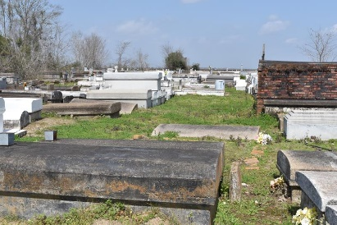

Deletha "Deedy" Danielle Shiloh, passed away at the age of 52, at St. James Parish Hospital, on July 20, 2021, after a valiant battle with a long-term illness.
Deletha was born on February 22, 1969, in Lutcher, LA, to Leanna Holmes Shiloh and Leroy Shiloh, Sr. She was devoted Christian and strong woman of faith.
She graduated from Lutcher High School in 1989. Following high school, she attended Technical College of Kenner, LA earned her certification in Early Childhood Development. She enjoyed reading, cooking, occasional shopping and the joy and devotion of caring for her family.
Left to cherish her precious memories are her mother, Leanna Holmes Shiloh, Paulina, LA; father, Leroy Shiloh, Sr. (Rosa); her two brothers, Leroy Shiloh Jr. (Brenda), Gonzales and Patrick Shiloh, Paulina, LA; Aunts, Brenda Clayton Speed (Gow), Lakeland, FL and Almeida Duperclay, Paulina, LA, Catherine McCrea, (Leon) Hammond, LA; a devoted sister/cousin Sharone Clayton Smith (Derrick) and host of other cousins, family, and friends.
Family and friends are invited to the Homegoing Celebration that will be held on Saturday, July 31, 2021, at 11:00 a.m. at Evergreen Baptist Church, 3399 LA-3125, Paulina, LA. Visitation will be at 9:00 a.m. until service time. Pastor Nolan Albert officiating. Interment at Antioch Cemetery. Viewing will be held Friday, July 30, 2021 from 3 p.m.- 5 p.m. at Bardell's Mortuary, 3856 LA-44, Mt Airy, LA 70076.
The Advocate, Baton Rouge, Louisiana
Jul. 29 to Jul. 31, 2021

