Kathleen (Bujol) Shorty
Abt. 1950 – December 14, 2020

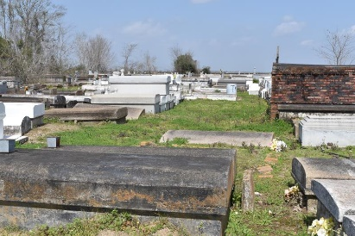

Kathleen Bujol Shorty departed this life on Tuesday, September 10, 2024 at the age of 65.
Daughter of the late Freddie and Rosa Lee Coates Bujol, Wife of the late Johnnie Shorty, Sr. Mother of Danyelle Bujol, Keokuk (DeVante) Jones, Constable Raymon (Brandy), Johnnie (Gina), Rhodesia, Johndell Shorty, and David Bradley. Kathleen is also survived by a host of grandchildren, two great-grandchildren, other relatives and friends.
A celebration service honoring her life and legacy will be held on Saturday, September 21, 2024 at King David B.C., 2329 N. King Ave., Lutcher, LA. Rev. Louis Watson Sr. officiating. Visitation begins at 11:00 am followed by service at 12 o'clock. Interment to followed at Antioch Cemetery Paulina, La. 70763. Arrangements for her final care entrusted with Hobson Brown Funeral Home, 134 Daisy St., Garyville, LA 70051, 985-535-2516.
The Times-Picayune, New Orleans, Louisiana
September 19-20, 2024

