Audrey (Vallery) Stewart

September 3, 1940 – October 7, 2003

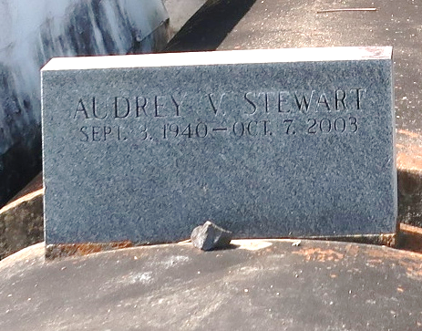

Audrey Vallery Stewart, a homemaker, died Oct. 7 of undetermined causes at New Orleans Home and Rehabilitation Center. She was 63. Mrs. Stewart was born in Central and lived in New Orleans.

Survivors include a son, Lance Stewart; two daughters, Cynthia and Janice Stewart; six sisters, Connie Kirklin, Laura Wadley of Convent, Mary Mullens of Baton Rouge, Dorothy Singleton and Tilda and Erma Vallery; four brothers, Ronald, Neal, Edmond and Leonard Vallery; 10 grandchildren; and seven great-grandchildren.

A funeral will be held today at noon at Mount Olive Baptist Church, 3143 Louisiana 642 in Paulina. Visitation is at 9 a.m. Burial will be in Antioch Baptist Church Cemetery. The Baloney Funeral Home is in charge of the arrangements.

Times-Picayune, The (New Orleans, Louisiana)

Tuesday, October 14, 2003