Bardell Lee Taylor
April 5, 1972 – January 21, 2021

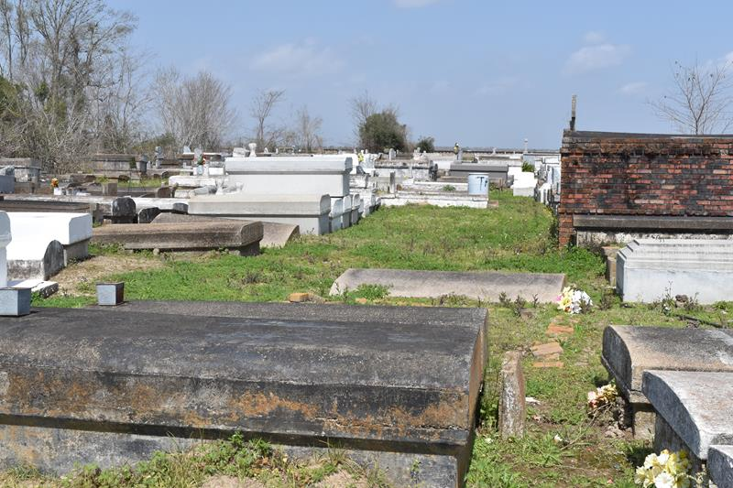

Bardell Lee Taylor departed this life on Tuesday, January, 12, 2021 at the age of 48.
Son of Mary Weber and George Winston, and he was reared by Charles Larry and Louella Slack. Husband of Lakeisha Taylor, father of Keia and Niya Taylor, grandfather of Kaston. Bardell is also survived by 3 sisters, 5 brothers, nieces, nephews and host of other relatives and friends.
Service will take place on Saturday, January 23, 2021 at King David B. C., 2329 King Ave., Lutcher, La. at 11 a.m. Rev. Ferdinand Wallace Jr. Officiant. Visitation from 9 a.m. until service time. Interment in Antioch Cemetery. Paulina, La.
Due to CDC (Covid 19) restrictions, seating is limited. Masks and social distancing are required. Professional services entrusted to the caring staff of Hobson Brown Funeral Home, 134 Daisy St., Garyville, La 70051, 985-535-2516.

Times-Picayune, The (New Orleans, Louisiana)
January 22-23, 2021

