Major Lee Taylor
1954 – May 31, 2016

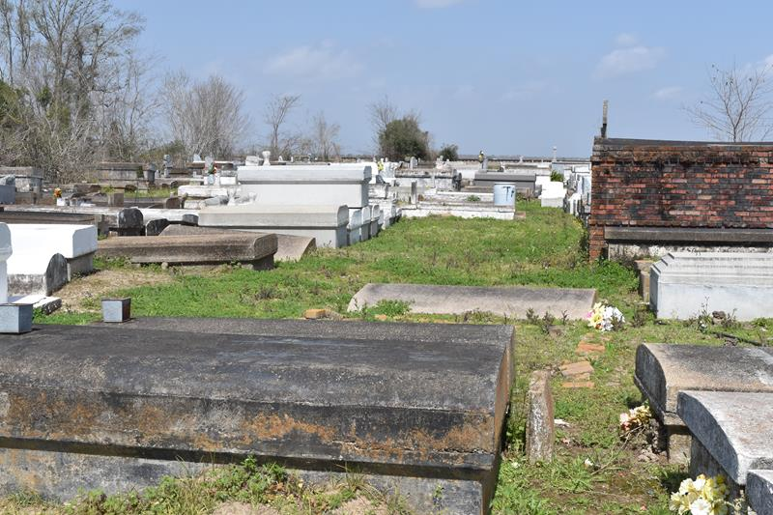

Major Lee Taylor at the age of 61 yrs. departed this earthly life on Monday May 31,2016 at his sisters residence in Lutcher, La.
Beloved son of the late Willie Taylor and Annie Louise Smith Taylor. He leaves to cherish his life memories two sisters Exie Payne and Mary Ann Taylor (Georgie), One sister-in-law Gertrude Taylor. Major Lee leaves to cherish his memories a host of nieces, nephews other relatives and friends. A native and resident of Lutcher.
He was preceded in death by his parents Willie Taylor and Annie Louise Smith Taylor, three sisters Betty Lee Taylor-Ross, Bernice Kelson and Syble Taylor; four brothers Lawrence Taylor (the late Willie Mae), Joe Frank Taylor (JoAnn), David Taylor and Samuel Taylor.
Pastors, Officers and Members of King David Baptist Church of Lutcher, La and all neighboring churches are invited to attend the home going celebration on Saturday, June 4, 2016 at 11:00am at King David Baptist Church, 2329 King Ave., Lutcher, La. Pastor Ferdinand J. Wallace officiating. Interment in Antioch Cemetery of Paulina, La. Visitation will be at the above name church from 9:00am until service time. Bardell's Mortuary of Mt. Airy, La. in charge. Information: 985-535-6837.

The Advocate, Baton Rouge, Louisiana
Jun. 2 to Jun. 4, 2016

