Alvin Ray Traveler
October 10, 1955 – January 31, 2023

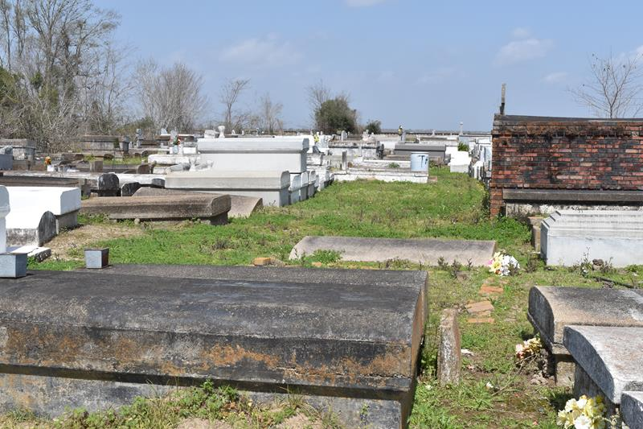

Alvin Ray Traveler, better known to all as "Ray", was born on October 10, 1955, to the Late Alvin and Shirley Traveler.
He was a very hard worker from an early age. Alvin worked for Triangle Fleet for many years before becoming ill. He resided at the Mid-City Nursing and Rehabilitation Center in Baton Rouge, LA until his death on Tuesday, January 31, 2023.
Alvin leaves a wealth of love and memories to be cherished by his daughter: Angele Scott (Daris); grandson, Daras Johnson; sisters, Rosalind Langford and Paulette Butler; brothers, Cornell Traveler and Kevin Traveler; and a host of nieces, nephews, other relatives, and friends. Ray's cousin, Adam Cooper, was always there to assist and care for him.
He is preceded in death by his parents, Alvin and Shirley Traveler; grandsons, Darell Scott, Darquel Scott, and Darvell Johnson; and sister, Anita Traveler.
Family and friends are invited to the homegoing celebration on Saturday, February 11, 2023, at 11 a.m. at Bardell's Mortuary, 3856 LA-44, Mt. Airy, LA 70076. Viewing will be from 10 a.m. until service time. Interment: Antioch Baptist Church Cemetery, Paulina, LA. Visitation will be held Friday, February 10, 2023, from 3 p.m. to 6 p.m. at Bardell's Mortuary.

The Advocate, Baton Rouge, Louisiana
February 10, 2023

