Alvin Turner
September 13, 1953 – May 10, 2023

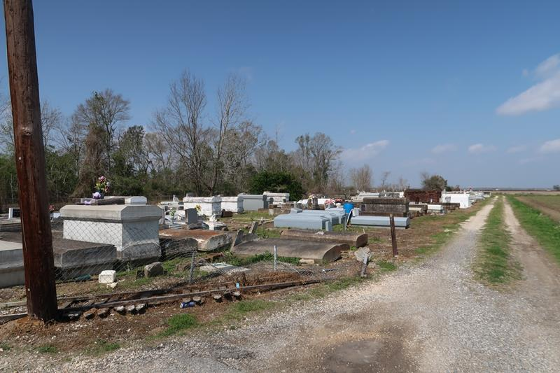

Rev. Alvin Turner transitioned to his eternal home on May 10, 2023. The Reverend's life began on September 13, 1953, in Houma, LA. He was born to the late Martha Turner and the late Freddie Ward and reared in Wallace, LA. He was the seventh of ten children.
Rev. Turner was educated in St. John Baptist Parish School System. He was baptized at an early age at Woodville Baptist Church. He received a Bachelor of Divinity from A.P. Clay Christian Bible College in Kenner, LA, and was a minister at Israelite Baptist Church, and later a Pastor in New Orleans, LA for numerous years.
He was a longshoreman by trade, and he also worked with River Parish Vault Company and later Economy Lounge until his retirement. He had a passion for drawing, singing, and praising God.
Rev. Alvin leaves to cherish his memories: his son, Cornel Turner; siblings, Philip Turner, Augustine Turner, Cleveland Turner, Jane T. Bejoile, Nolan Turner, a devoted sister, Christine Ward, and Martha Sam; one aunt, Audrey Alridge of Houma, LA; seven grandchildren; one great grandchild; two devoted nieces, Trenell Bujol and Ursala Ward; a devoted best friend, Levy; and a host of nieces, nephews, other relatives and friends.
He is preceded in death by his son, Alvin Turner Jr. and siblings, Eddie Turner, and Lucille T. Kelson.
Family and friends are invited to the celebration of life on Thursday, May 18, 2023, at 10 am at St. Mark Baptist Church, 132 Marques St. Mt. Airy, LA. Pastor Oscar R. Nelson, officiating. Visitation is from 9 am until service time. Interment will be at Antioch Cemetery, Paulina, LA. Viewing will be held Wednesday, May 17, 2023, from 3 pm to 6 pm at Bardell's Mortuary, 3856 LA-44, Mt. Airy, LA.
The Advocate, Baton Rouge, Louisiana
May 17, 2023

