Ollie Turney
Unk. 15, 1914 - 1973

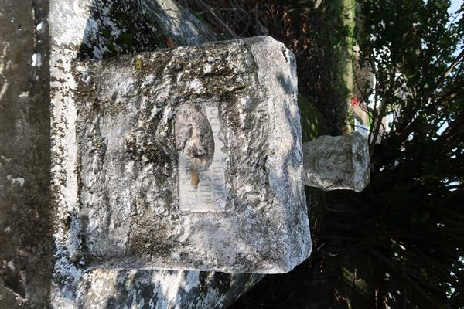

No further information found at this time.

