Frederick Marquese Ursin
September 4, 1979 – May 25, 2001

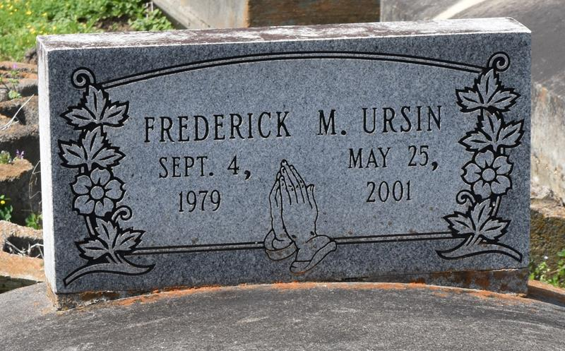

Mr. Frederick Or Fred Ursin, 21
Frederick "Fred" Ursin died Friday from injuries sustained in a car accident in Bristol, Tenn. He was 21. Mr. Ursin lived in San Antonio for the past three years. He attended Wilkinson County High School and received an associates degree in electrical engineering. Survivors include his father, Molen Ursin; three brothers, Ricou, Travis and Calvin Ursin of Woodville, Miss.; two sisters, Carisa Ursin of Alexandria, Va., and Nicole Jones of Merritt Island, Fla.; and a stepmother, JoAnne Ursin. A funeral will be held Friday at 7 p.m. at Wilkinson County High School in Woodville. A dismissal service will be held Saturday at 11 a.m. at Evergreen Baptist Church in Paulina. Burial will be in Antioch Cemetery in Paulina. Bardell's Mortuary is in charge of arrangements.
Times-Picayune, The (New Orleans, Louisiana
Thursday, May 31, 2001
**

URSIN PAULINA - Frederick Marquese Ursin, 21, a resident of Paulina, died May 25 in an automobile accident in Bristol, Tenn. He was the son of Molen and the late Geraldine Ursin and brother of Carisa Ursin, Nicole Jones and Ricou J., Travis, Calvin and the late Trashira Ursin. Dismissal services are today at 11 a.m. at Evergreen Baptist Church, Paulina, with interment at Antioch Cemetery, Paulina.

L'Observateur (La Place, Louisiana)
Saturday, June 2, 2001

