Geraldine Jean Ursin
November 13, 1956 – May 25, 2002

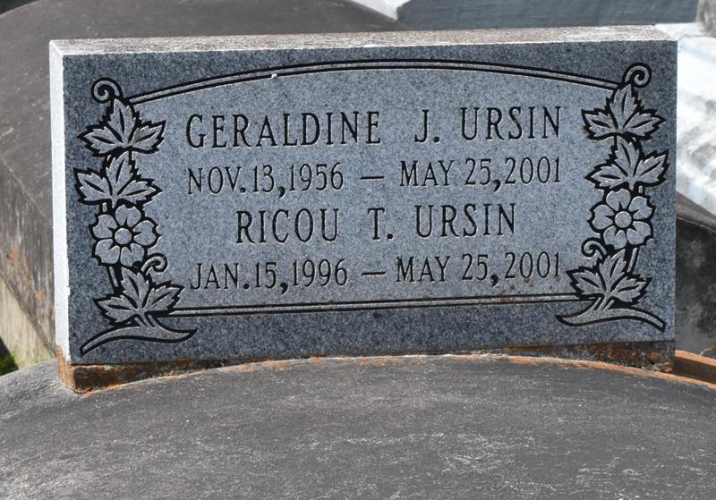

Ms Geraldine Or Jean Ursin, 46
Geraldine "Jean" Ursin, a homemaker, died Friday from injuries sustained in a car accident in Bristol, Tenn. She was 46. Ms. Ursin had lived in Woodville, Miss., for the past 13 years. She attended Lutcher High School and was a member of Morning Star Baptist Church in Woodville. Survivors include three sons, Ricou, Travis and Calvin Ursin, all of Woodville; a daughter, Carisa Ursin of Alexandria, Va.; a sister, Jerry Mae Clayton; and three grandchildren. A funeral will be held Friday at 7 p.m. at Wilkinson County High School in Woodville. A dismissal service will be held Saturday at 11 a.m. at Evergreen Baptist Church in Paulina. Burial will be in Antioch Cemetery in Paulina. Bardell's Mortuary is in charge of arrangements.
Times-Picayune, The (New Orleans, Louisiana)
Thursday, May 31, 2001
**

URSIN PAULINA - Geraldine "Jean" Ursin, 46, a native of Paulina and resident of Woodville, Miss. for the past 13 years, died May 25 in an automobile accident in Bristol, Tenn. She was the mother of Carisa, Ricou, Travis, Calvin and the late Frederick and Trashira Ursin. She was also the sister of Jerry Mae Clayton. She is also survived by three grandchildren. She attended Lutcher High School. In the same accident, Frederick Ursin, 21, Trashira Ursin, 16, and grandchild, Ricou Terrell Ursin, 5, also died. Dismissal services are today at 11 a.m. at Evergreen Baptist Church, Paulina, with interment at Antioch Cemetery, Paulina.

L'Observateur (La Place, Louisiana)
Saturday, June 2, 2001

