John Joseph Vallery/Valry
June 24, 1916 – August 23, 1994

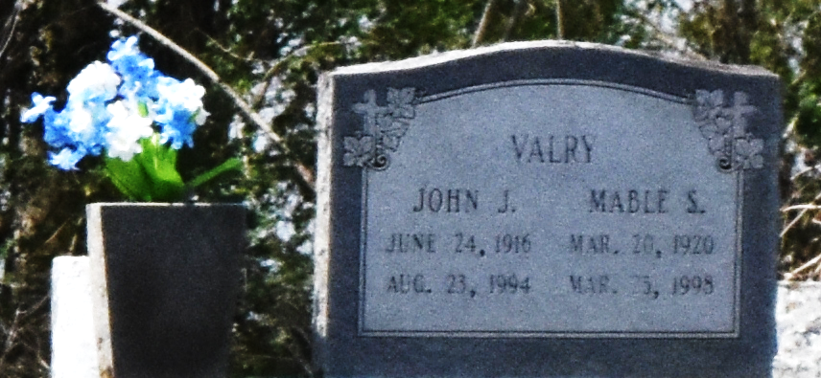

John Joseph Vallery, seventy-eight years of age, passed away on August 23, 1994 at Acadian Nursing Home. He was a resident and native of Convent.

He is survived by his wife, Mable Stewart Vallery; seven daughters, Mary, Audrey, Dorothy, Irma, Tilda, Connie, and Laura; six sons, Raymond, Wallace, Edmund, Leonard, Ronald, and Neal; a sister, Doretha Hampton; two brothers, Jacob and Amos Vallery; thirty-one grandchildren, and twenty-four great-grandchildren.

He was preceded in death by parents, Edmund and Mary Vallery; three sons, Joseph, Alvin and Bernard; a sister, Rosie Ross; and a brother, Fritz Gussett.

Unknown source
**

U.S., Social Security Death Index, 1935-2014

Name John J. Vallery
Social Security Number xxx
Birth Date 24 Jun 1916
Issue year Before 1951
Issue State Louisiana
Last Residence 70723, Convent, Saint James, Louisiana, USA
Death Date 23 Aug 1994

