Leonard Vallery Sr.
June 28, 1949 – February 18, 2021

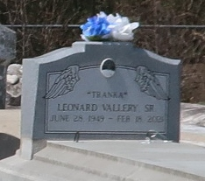

Leonard Vallery, Sr. departed this life on Thursday, February 18, 2021 at Clarity Hospice in Baton Rouge, at the age of 71.
Son of the late John and Mable Vallery. Husband of Annabell Shorty Vallery, father of Linda and Leonard Vallery, Jr. Leonard is also survived by his 8 grandchildren, 4 sisters, 2 brothers and a host of nieces, nephews, other relatives and friends.
Homegoing celebration Service will take place on Saturday, February 27, 2021 at Hobson Brown Funeral Home, 134 Daisy St., Garyville, La., at 11:00 am. Visitation from 10 am until funeral time (only). Burial on Antioch Cemetery, Paulina, La. Due to CDC (COVID-19) restrictions, seating is limited. Masks and social distancing are required. Professional services entrusted to the caring staff of Hobson Brown Funeral Home, 134 Daisy St., Garyville, La 70051, 985-535-2516.
The Times-Picayune, New Orleans, Louisiana
Feb. 25 to Feb. 27, 2021

