Mable (Stewart) Vallery/Valry
March 20, 1920 – March 25, 1998

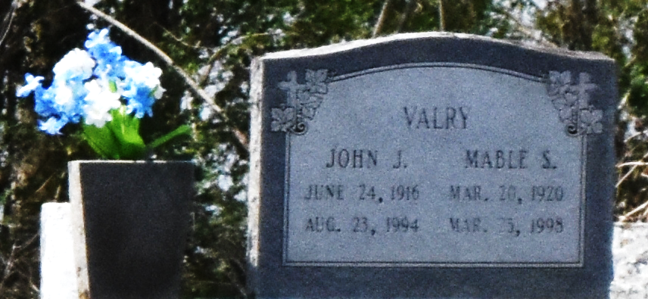

Mable Stewart Vallery, seventy-eight years of age, passed away on March 25, 1998 at River Parishes Hospital. She was a resident of Convent and a homemaker.
She is survived by seven daughters, Mary V Mullens, Audrey M Stewart, Erma L Vallery; Tilda Vallery, Connie V Kirklin, Laura A Watllay, Dorothy V Thomas; six sons, Wallace, Raymond, Edmund, Leonard, Ronald, and Neal Patrick Vallery; a sister, Beatrice Devare; thirty-five grandchildren and thirty-two great-grandchildren.
She was preceded in death by her parents, Clarence and Angeline Nichols Stewart; her husband, John J Vallery; three sons, Joseph, Alvin, and Bernard Stewart; two sisters, Cecile Davis and Mary Smith; and two brothers.

Unknown source

