William Alexander Variste
March 8, 1922 – February 7, 1996

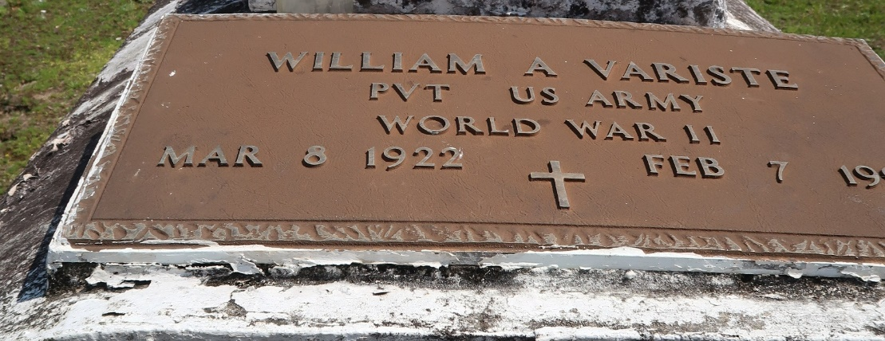

U.S., Department of Veterans Affairs BIRLS Death File, 1850-2010

Name William A Variste
Gender Male
Birth Date 5 Mar 1922
Death Date 7 Feb 1996
Cause of Death Natural
SSN xxx
Enlistment Branch ARMY
Enlistment Date 19 Jul 1941
Discharge Date 19 May 1946
Page number 1
**

William Alexander Variste from tree hermitage enslaved community 2019

Birth 5 Mar 1922 Louisiana, USA
Residence 1997 Reserve, St John the Baptist, Louisiana, USA
Death 7 Feb 1996 St John the Baptist, Louisiana, USA
3267 People 6 Records 6 Sources
**

William Alexander Varice (Variste) from tree De'Andreia Joseph Family Tree

Birth 8 Mar 1922 Louisiana, USA
Death 7 Feb 1996
Father Oleraude Varice (Variste) (Born 1872)
Mother Rosaline (Rose) Varice (Variste) (Born 1866)
211 People 0 Records 2 Sources

