Kenneth Avery Victor
April 27, 1956 – March 2, 2021

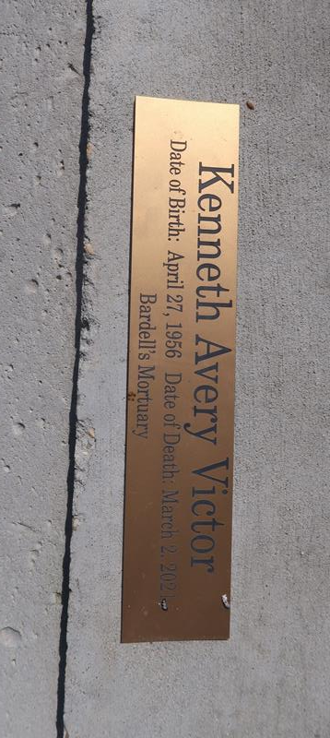

Kenneth Victor departed this earthly life and entered eternal rest March 2, 2021.

He was born April 27, 1956 to the union of Chester and Myrtle Victor Sr. He leaves to cherish his memories his children, grandchildren, brothers, sisters, aunts, uncles, nieces, nephews, other relatives, and friends.

Family and friends are invited to the homegoing celebration on Saturday, March 13, 2021 at 11 a.m. at Rescue Mission Baptist Church, 361 East 14th St., Reserve, LA 70084. Reverend Devon Mason officiating. Visitation from 9 a.m. until service time. Interment: Antioch Cemetery, Paulina, LA. Viewing will be held on Friday, March 12, 2021 from 4 p.m. until 7 p.m. at Bardell's Mortuary, 3856 LA-44, Mt. Airy, LA 70076. Due to COVID-19, masks and social distancing will be enforced. Services entrusted to Bardell's Mortuary. Information: (985) 535-6837.

New Orleans Advocate, The (Louisiana)
Thursday, March 11, 2021

