Leroy Washington Sr.
Abt. 1937 – January 16, 2003

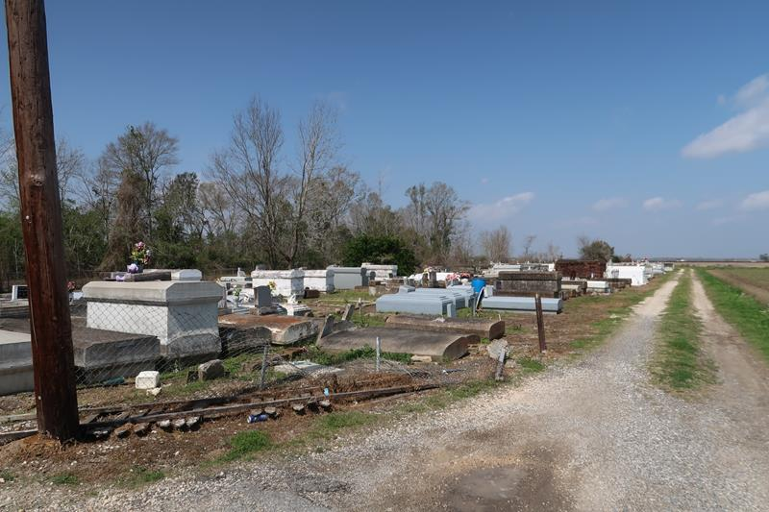

Leroy Washington, Sr., at his residence, Paulina, LA at 6:10 P.M. on Wednesday, January 15, 2003. Son of the late Junius Washington and Minerva Givens Washington. Husband of Louise Miller Washington of Paulina, LA. Father of Deidra Tuircuit, George, Jerry, Tyrone, Darnell, Cedric, Sr., and Leroy Washington, Jr. Brother of Delores Williams, Ruth Brooks, Lattie Richardson, Ulysses, Sr., Morris, Percy, Berman, Charles Sr., Ferdinand Washington, Sr., the late Joseph and Herman Washington. Also survived by 22 grandchildren, 2 step-grandchildren, 5 step-great-grandchildren, numerous neices, nephews, cousins, sisters and brothers-in-law, a son-in-law; Michael Tuircuit, Jr., 2 daughters-in-law; Paulette and Nakeita Washington, other relatives and friends. Age 66 years. Visitation at Mt. Olive Baptist Church, 3143 Highway 642, Paulina, LA, Monday, January 20, 2003 from 9:30 A.M. until Religious Services at 11:00 A.M. Conducted by The Rev. Elmo Lee. Burial in Antioch Cemetery, Paulina, LA. BRAZIER-WATSON FUNERAL HOME IN CHARGE OF ARRANGEMENTS.

The Times-Picayune, New Orleans, Louisiana
Jan. 19, 2003
**

PAULINA – Leroy “Nealy” Washington Sr., 66, a native and resident of Paulina, died Jan. 16. He was the husband of Louise Miller Washington and father of Deidra Tuircuit, Leroy Jr., George, Tyrone, Cedric and Jerry Washington. He was the son of the late Junius and Minerva Givens Washington, and brother of Delores Williams, Ruth Brooks, Lattie Richardson, Morris, Percy, Berman, Ulysses Sr., Charles Sr. and Ferdinand Washington Sr., and the late Joseph and Herman Washington. He is also survived by 22 grandchildren, two step-grandchildren and five step-great-grandchildren. He was a retired construction worker at Boh Brothers Construction Co. Services were Jan. 20 at Mt. Olive Baptist Church, Paulina, with interment at Antioch Cemetery, Paulina.

L’Observateur, LaPlace, Louisiana
Tuesday, January 28, 2003

