Leroy Wells

June 30, 1946 – November 14, 2022

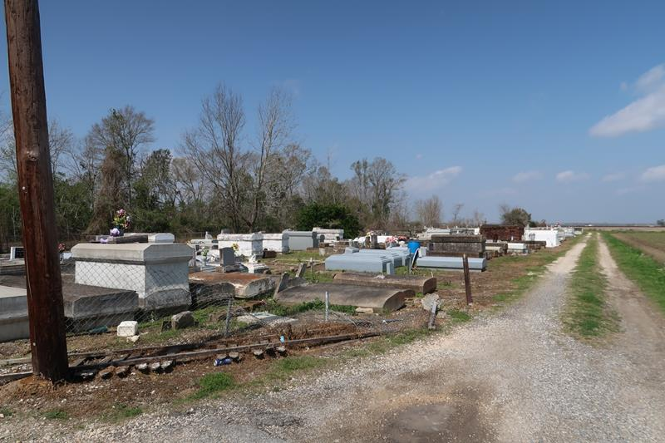

Leroy "Goody" Wells was born on June 30, 1946, In Carpenter, MS to the late Mamie L. Bradley Davis and Samuel King. He was Mamie's oldest and only son.  
 Leroy met Donna Albert in high school and later married his high school sweetheart on February 14, 1968. Together this union was blessed with 4 children: Rhonda Wells, Leroy (Raynell) Wells, Jacquia Wells, and Rondez (Kira) Wells; one other daughter, Chantrell Burl. Leroy also cherished his siblings: Imogene Watson of Lutcher, Jacqulian D. Aubert of Gramercy, Sandra F. Martin of Gramercy, Gwendolyn Franklin of Paulina, Kathaleen (Chadwick) Gauthreaux of Convent, Loretta (Alonzo) Craighton of Prairieville, Alma Holley of Gramercy, Lucille (Leroy) Gaines, Linda (Lawrence) Mack, Bobby Mosby, Brenda Lee, Lionel (Bonita) King, Jerry (Brenda) King, Willie (Sharon) King, Robert (Estella) King, Kent (Debra) King, and Eddie (Shirley) King all of Mississippi.  
 Leroy was educated in the St. James Parish School System. He graduated from Cypress Grove High School in 1965. He later entered the job core and from there he graduated as a butcher.  
 Leroy accepted Jesus Christ and was baptized at an early age at King Solomon Baptist by Pastor Benjamin Scott. His favorite scripture was Proverbs 3: 5-6, "Trust in the Lord with all your heart and lean not on your own understanding; In all your ways acknowledge him, and he shall direct your paths".  
 Leroy was employed with Veron Provision in Lutcher, LA. He later worked at Avondale Shipyard in Avondale, LA. Leroy went on to work for Colonial Sugar Refinery. He retired from St. James Parish Utility after working with them for 25 years.  
 Leroy was an active member of the Lutcher Sportsman League and Black Hawk Motorcycle Club. He was also known for his signature dance and being the life of the party.  
 On Monday, November 14, 2022, God put His arms around Leroy and whispered, "Come to me". At that time Leroy departed his earthly life and entered eternal rest with his heavenly father.  
 Leroy leaves to cherish his beloved memories to his wife of 55 years: Donna Wells, 5 children; 18 grandchildren, and 4 great-grandchildren. He is also survived by his siblings, 1 sister-in-law: Addie Cooper, 7 Godchildren: Robert "Hobo" Taylor, Tonika Washington, Arlene Bridges, Carla Williams, Jermenae' Fluence, Arlyn Johnson, and Edward "Ben" Banks, devoted friends: Leonard Fluence, Derrick Smith, and James "Zickel" Kirklin. He will also be missed by a host of nieces, nephews, other relatives, and friends.  
 He was preceded in death by his parents: Mamie B. Davis and Samuel King; grandmother: Alma Woods Bradley; grandfather: Robert "Bo" Bradley; siblings: Shirley B. Morris, Glenda King, and Samuel King Jr; 5 aunts: Lillian Harton, Jacquline Williams, Lorraine Clayton, Mable Smith, and Lowell Fishback; 1 uncle: Thomas C. Bradley; mother-in-law: Mamie Davis Albert; father-in-law: Johnnie Albert; and sister-in-law: Fannie Jones.  
 A celebration of life honoring Leroy "Goody" Wells will be held on November 26, 2022, at King Solomon Baptist Church, 2385 N Courseault St, Lutcher, LA 70071. Visitation 8am-10am. Service will begin at 10am. Interment to follow at Antioch Cemetery in Paulina, LA.

Treasures of Life Funeral Services, Gramercy, Louisiana