Artemise Ezidore Williams
September 16, 1920 – February 27, 2011

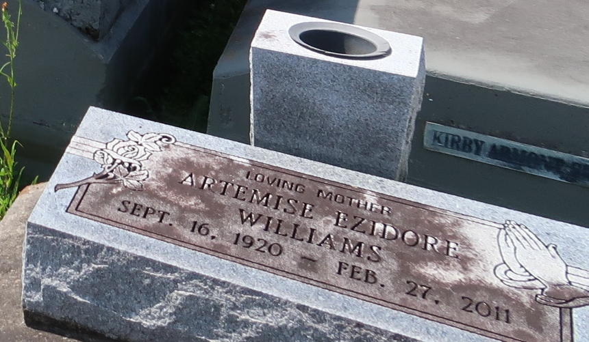

A native of Paulina and a resident of Lutcher, she died Sunday, Feb. 27, 2011, at River Parish Hospital in LaPlace. She was 90.

Visiting at First Community Antioch Baptist Church, Lutcher, on Saturday, March 5, from 9:30 a.m. until religious service at 11 a.m., conducted by the Rev. Ferdinand Gaines Jr. Burial in Antioch Cemetery, Paulina.

Arrangements by Brazier-Watson Funeral Home, Donaldsonville.

Advocate, The (Baton Rouge, Louisiana)
Friday, March 4, 2011

