Jaunique Lynell Williams
August 16, 1982 – December 24, 2009

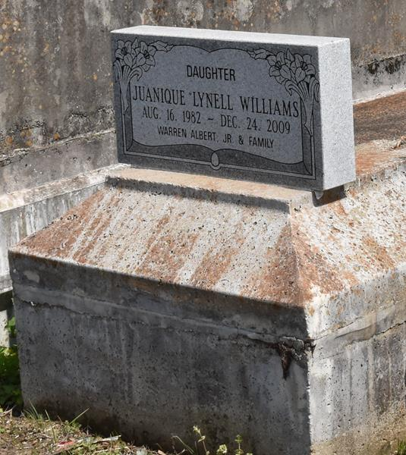

A native and resident of Convent, she died at 3:15 a.m. Thursday, Dec. 24, 2009, at Canon Hospice in Jefferson. She was 27.
Visiting at First Community Antioch Baptist Church, Lutcher, on Thursday, Dec. 31, from 9:30 a.m. until religious service at 11 a.m., conducted by the Rev. Ferdinand Gaines. Interment in Antioch Cemetery, Paulina.
She is survived by her mother, Norma Williams; father and stepmother, Warren Albert and Carrie Albert; sisters, Kannielell Williams, Desiree Steer, Mayola and husband Jason Lindsey, and Reva Davis; brothers, Ricardo Williams and Jeremy Albert; stepbrother, Bron Walker; aunts, uncles, nieces, nephews, cousins, other relatives and friends.
She was preceded in death by her maternal grandfather, Marshall Williams Sr.; and paternal grandfather, Warren Albert Sr. Arrangements by Brazier-Watson Funeral Home of Donaldsonville.

Advocate, The (Baton Rouge, Louisiana)
Wednesday, December 30, 2009

