Murray Williams Sr.

January 3, 1956 – September 30, 2010

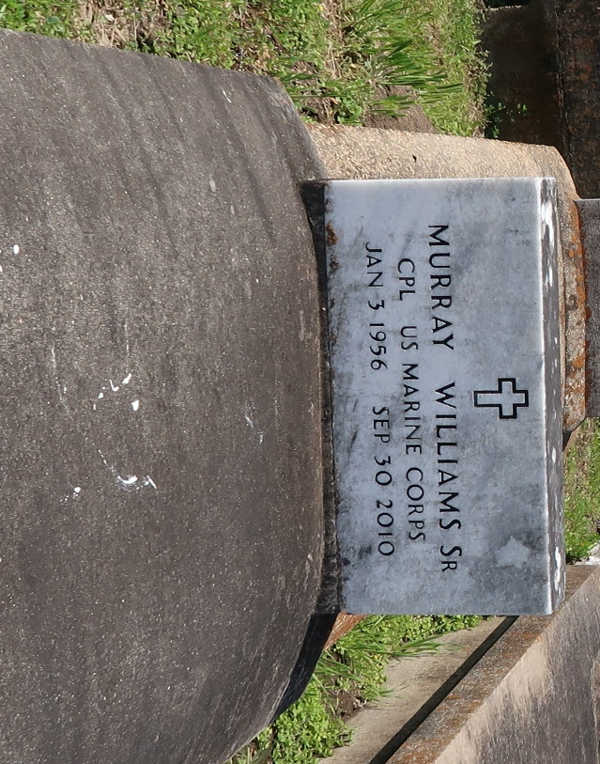

A resident of Lutcher, he died at 3:15 a.m. Thursday, Sept. 30, 2010, at Tulane Medical Center, New Orleans. He was 54 and a native of Paulina.

Visiting at First Community Antioch Baptist Church, La. 3125, Lutcher, Saturday, Oct. 9, from 9:30 a.m. until religious service at 11 a.m., conducted by the Rev. Ferdinand Gaines Jr. Interment in church cemetery.

Survived by his mother, Artemise Ezidore Williams; wife, Cassandra Green Williams; daughter, Chantell and husband Cody Long; two sons, Murray Jr. and wife Ranata, and Ricardo and wife Andria Williams; son-in-law, Marlon Washington; four sisters, Annie Lee and husband James Emery, Artemise and husband Joe Bernard, Stella and husband Larry James and Norma and husband Larry Williams; three brothers, Sidney and wife Jackie Williams, Randy and wife Judy Williams and Marshall Williams Jr.; brother-in-law, Dow and wife Terry Lynn Green; mother-in-law, Rosa Lee Cooper; 12 grandchildren, nieces, nephews, cousins, other relatives and friends.

Preceded in death by his father, Marshall Williams Sr.; daughter, Calebra Washington; father-in-law, Adam Cooper Sr.; and sister-in-law, Debra Diggs.

Arrangements by Brazier-Watson Funeral Home, Donaldsonville.

Advocate, The (Baton Rouge, Louisiana)

Friday, October 8, 2010