Tyrone Williams
November 23, 1951 – December 13, 2011

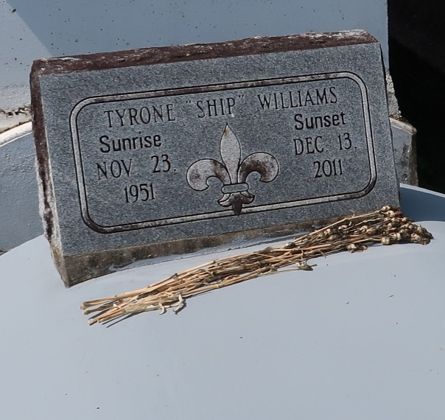

Tyrone "Ship" Williams died at Ochsner Foundation Hospital in Jefferson at 10:40 a.m. Tuesday, Dec. 13, 2011. He was 60.

Visiting at New Zion Christian Center, Gramercy, on Saturday, Dec. 17, from 9:30 a.m. until services at 11 a.m. Interment in Antioch Cemetery, Paulina. Arrangements with Brazier-Watson Funeral Home of Donaldsonville.

Advocate, The (Baton Rouge, Louisiana)
Friday, December 16, 2011

