Tyrone Tyboo Williams
November 25, 1968 – September 4, 2005

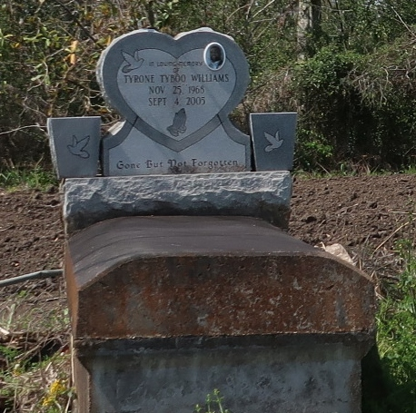

Tyrone Williams died Sunday, Sept. 4, 2005, at approximately 8 p.m., with his wife, Spring Vasham Williams, as the result of a motorcycle accident in Texas. He was 36.
Visiting at First Community Antioch Baptist Church, La. 3125, Lutcher, on Monday, Sept. 12, from 5 p.m. until religious service at 7:30 p.m., conducted by the Rev. Ferdinand Gaines Jr. Dismissal on Tuesday, Sept. 13, at 10 a.m. Interment in church cemetery.
He is survived by his mother, Felicia Davis Williams Smith; daughter, Abigail Williams; two stepdaughters, Autumn and Summer Vasham; maternal grandfather, Amos Johnson Sr.; sister, Yolanda Smith; two brothers, Carl Davis and Barry Williams; aunts and uncles, including Annie Carr, Nitrea and Vincent Allen, Rosemary Albert, Bertha Williams, Lillian and Alvin Price, Ora Bell and Charles Bazile, Amos and Lyn Johnson, Robert and Larry Davis, Theron Jones and the Rev. Clarence Williams; and numerous nieces, nephews, cousins, other relatives and friends.
He was preceded in death by his father, James H. Williams Jr.; paternal grandparents, the Rev. James Sr. and Lillian Williams; maternal grandmother, Albertha Davis Collins; stepfather, Herbert Smith; and uncles, Thomas Price and Ellis Albert. Brazier-Watson Funeral Home, Donaldsonville, is in charge of arrangements.

Advocate, The (Baton Rouge, Louisiana)
Monday, September 12, 2005

