Isabella Wooden
April 21, 1923 – July 25, 1993

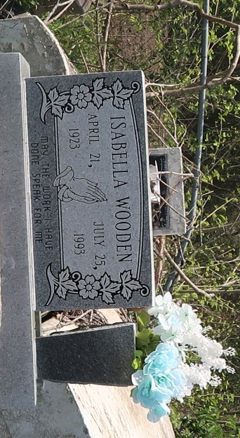

U.S., Social Security Applications and Claims Index, 1936-2007
Name Isabella Wooden
Gender Female
Race Black
Birth Date 21 Apr 1923
Birth Place New Orleans, Louisiana
[St James, Louisiana]
Death Date 25 Jul 1993
Father Alex Wooden
Mother Gertie White
SSN xxx
Death Certificate Number 21/346
Notes Jul 1941: Name listed as ISABELLA WOODEN

