Hayward Batiste, Jr.
June 6, 1969 – March 24, 2024

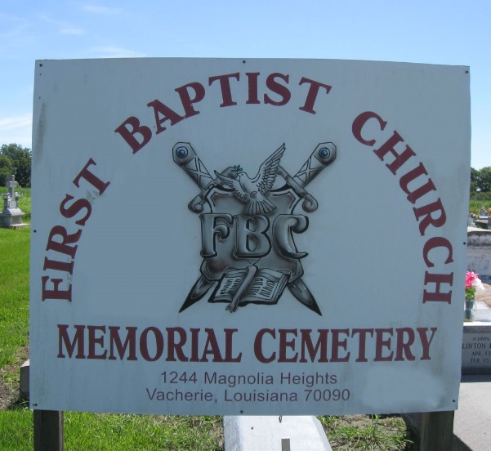

On Sunday, March 24, 2024, Hayward Batiste Jr. of Vacherie, La was a loving father, son, brother, uncle, cousin, parrain, friend and brother-in-law, whom transitioned from this life into God’s arm at the age of 54.
Hayward Batiste Jr. was born on June 3, 1969, to the union of the late Hayward Batiste, Sr. and Nettie Ann Batiste of Vacherie, La. Hayward believed in God and kept his faith during his life here on earth. He was baptized by the late Lucien R. Garrett at First Baptist Church. Hayward was educated in the public schools of St. James Parish and was a part of the class of ‘88. Hayward was to never marry, but he was blessed in July of 1986 with a daughter, Amanda Armant-Lumar of Laplace, La.
Hayward was compassionate, giving, funny, outspoken, loved to dance and loved his family and friends. He was preceded in death by his father, Hayward Batiste Sr., his grandparents, Equator Batiste, John Batiste, Isabella Jacob Costly, Benny Costly and his devoted friend, Norman Armant.
Hayward leaves to cherish his memories: his mother, Nettie Ann Batiste, his daughter Amanda Armant-Lumar (Reshide), his grandchildren, Reshide Armant and Reign Lumar, his brother, Brad Batiste (Deshanna), his sisters, Kim Jairles (Owen), Shelly Celestine (Greg) and Carol Batiste, his devoted cousin, Barry Batiste, and devoted friend, Irma Armant, St. James High Class of ‘88, god children, Crashada Jackson (Robert) and Dalaysia Armant, nieces and nephews, Taquincia Jairles, Valencia Jairles, Trey Jairles, Gregory Celestine (Vanita), Aria Broden (Aronius), Ariel Celestine, Arrieon Celestine, Brad Batiste Jr., Bryce Batiste, Brennan Batiste, Brielle Batiste, Jared Batiste, Jaleesa Batiste and host of great nieces and nephews, other relatives and friends.
A Celebration of life will be held on Saturday, April 6, 2024, at First Baptist Church of Vacherie, 1244 Magnolia Heights St., Vacherie, La 70090. Visitation beginning for 9am with service to follow for 11am. Pastor Johnnie B. Magee, Jr. officiant. Interment First Baptist Church Cemetery.

Treasures of Life Funeral Services, Gramercy, Louisiana
April 7, 2024

