Napoleon Carey, Jr.
July 1, 1942 – January 11, 2024

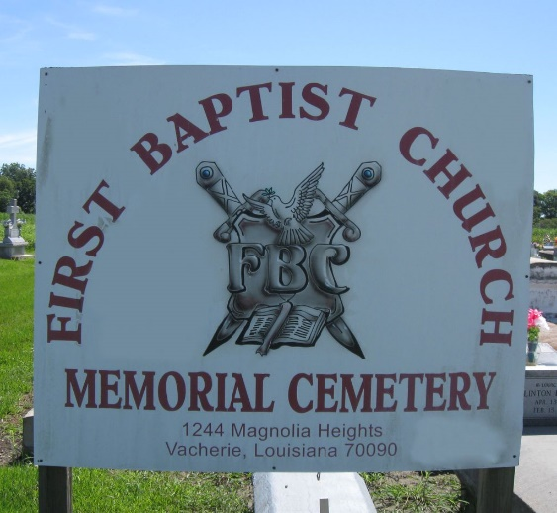

A Time to Be Born: Reverend Napoleon Carey, Jr. was born on July 1, 1942 to the late Napoleon W. Carey, Sr. and Lebora Thomas Carey. He was an avid fan of Drag Racing, a member of Ebenezer Lodge # 70, and Eureka Consistory No. 7, 32nd Degree Masons. He was affectionately called many names by his family: Mile, Lil Nip, and Tony Rome. Being the oldest son reared in the home, he decided to follow in the footsteps of his father and enroll in the military in 1967.
A Time to Flourish: Reverend Carey was brought up in a Christian environment and was taught the word of God as a young child. He received Christ on February 14, 1971 and was baptized by the late Rev. Maxwell Cage, Sr. After baptism, he started teaching Sunday School at First Baptist and later taught various men classes at other churches. He later attended the Seminary and earned his Doctor of Divinity. Napoleon served as an Associate Minister here at First Baptist Church, Greater Golden Grove Baptist Church, and Mount Olive Baptist Church. Additionally, he served on several committees in church and continued being an inspiration to others on a daily basis. He was a graduate of Magnolia High School in 1960.
A Time to Love: He was blessed with three children: Marvin Kenner, Christopher DeVar Carey, Sr., and Reiko Angelle Carey.
A Time to Die: (Ecclesiastes 3) Reverend Carey departed this life on Thursday, January 11, 2024 at the Veterans Affairs Hospital in New Orleans, Louisiana. He leaves to cherish his loving memories: his three children-Marvin Kenner (Yasmin), Christopher DeVar (LaDrika), and Reiko Angelle Carey. He also leaves to cherish his grandchildren: Danielle, Isaiah, Christopher Jr, and Chrissette Carey; one great-grandchild- Alana Raquel Williams. He was the brother of: Janice Lee Carey-Meeks (Joe Meeks), Berlin Carey, Leslie Carey, and an adoptive sister/cousin-Charlene Favorite Williams. Napoleon was the uncle of Kirk (Erica) and Byron Carey (Kim), Glenice and Aaron Carey, Chermeeka Meeks, and Allen Batiste. He also leaves to cherish numerous nieces, nephews, cousins, and devoted friends he met in the ministry.
He was preceded in death by his parents: Napoleon Sr. and Lebora Thomas Carey, his eldest sister-Claudia Jean Carey; nephew-Reginald Carey; sister-in-law Ida Carey; grandparents: Mrs. Sedonia Thomas, Mrs. Claudia Jones and Mr. Paul Jones, six aunts and one uncle: Esther Favorite, Aserine Smith, LeAnder Jacobs, Eula Mae Mitchell, Helen Carey-Lee, Lucy Johnson, and Elijah Thomas.
A Celebration of Life honoring Napoleon Carey, Jr. will be held on Friday, January 19, 2024, at First Baptist Church, 1244 Magnolia Heights St., Vacherie, LA 70090. Visitation beginning at 9AM with service beginning at 11AM. Dr. Leonard L. Favorite, Sr., officiant. Interment to follow at First Baptist Church Cemetery.

Treasures of Life Funeral Services, Gramercy, Louisiana
January 23, 2024

