Genevieve (Young) Scott
July 7, 1936 – April 14, 2024

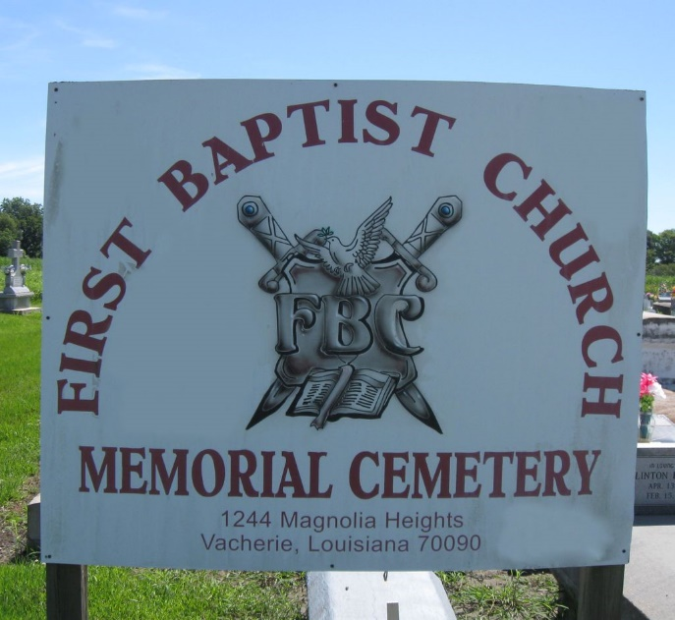

Genevieve Scott departed this life on Sunday, April 14, 2024. She was born to the union of the late Willis Young, Sr. and Ismay Benoit Young on July 7, 1936. Genevieve graduated from Magnolia High school, then went on to pursue both her bachelor's and master's degrees from Southern A&M University in Baton Rouge, LA. She went on to teach and tutor for many years.
Genevieve was preceded in death by her parents; siblings: Hilton Young, Owen Young, Sr., and Ismay Jones. She is survived by her eldest brother: Willis Young, Jr., and a host of relatives.
Funeral services for Genevieve Scott will be held on Friday, April 19, 2024, at First Baptist Church, 1244 Magnolia Heights St., Vacherie, LA 70090. Visitation beginning at 9AM. Service to follow at 11AM. Pastor Johnnie B. Magee, Jr., officiant. Interment at First Baptist Church Cemetery.

Treasures of Life Funeral Services, Gramercy, LA
April 19, 2024

