Clarence Walters Sr.

January 24, 1922 – January 2, 1994

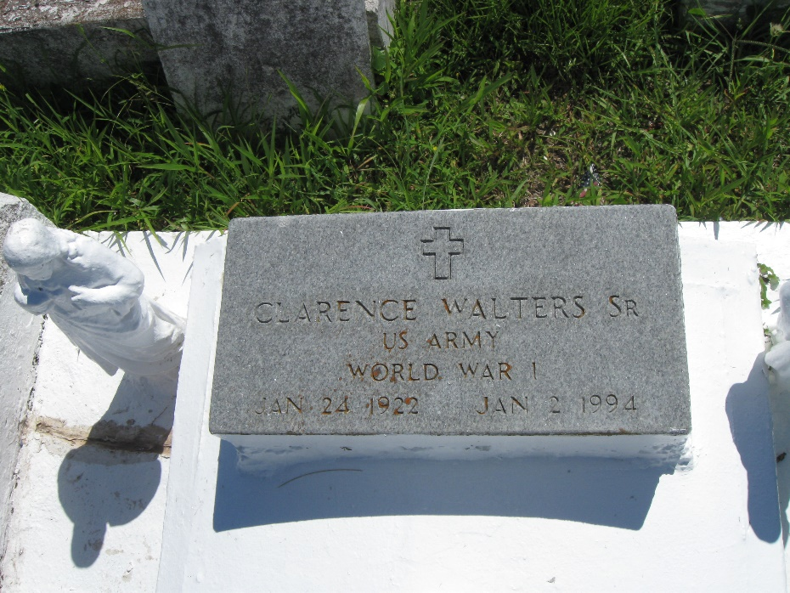

Photo by rw2009

Clarence Walters

A funeral is scheduled for 11 a.m. Friday at Highway Baptist Church in Vacherie for Clarence Walters Sr., 71, a resident of Vacherie, who died Sunday, Jan. 2.

Visitation will be 5 to 8 p.m. today and 9 a.m. to funeral time Friday at the church. Burial will be in the church cemetery.

He was the husband of Adline Monget Walters of Vacherie; father of Clarence Jr., Hamilton, Gloria J and Patricia A. Walters, Faye Gordon, Oscar and Winley Stewart, all of Vacherie.

He is also survived by 20 grandchildren and 3 great-grandchildren.

He was preceded in death by his parents, Mr. and Mrs. Luverta Antoine Walters; a son, Nolan Stewart; a grandson, Oscar Stewart Jr.; a brother, Ernest Thomas; and a sister, Louise Thomas. Southall-Westside Funeral Home of Vacherie is in charge of arrangements.

Unknown newspaper clipping