Albert Pierre Falgoust Jr.

November 11, 1904 – February 21, 2002

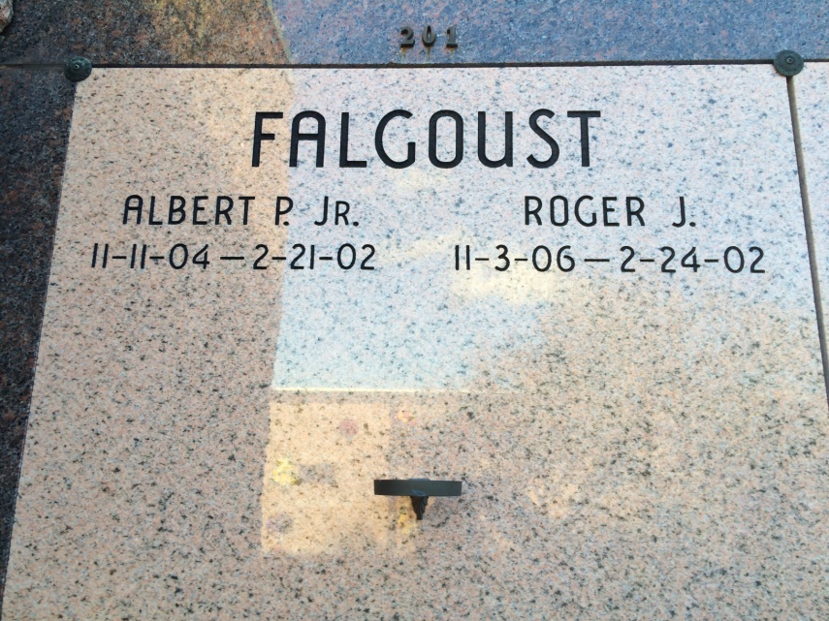

Photo by Kerry Keller

Albert Pierre Falgoust, Jr. on Thursday, February 21, 2002 at 1:32 p.m. in Thibodaux, LA. Son of the late Albert P. Sr. and Emilda Rome Falgoust. Brother of Roger Falgoust, Thibodaux, LA, the late Christine, Adelta and Laura Falgoust, Louise LaFranz, Helen Rome and Victor Rome. Uncle of Raymond Rose, Darlene Bergens and Gerald Rome, Sr. Also ten great-nieces and nephews. Age 97 years. A native of Vacherie, LA and a resident of St. James, LA.  
  
Mass of Christian Burial at 11:30 a.m. on Tuesday, February 26, 2002 at St. James Catholic Church, St. James, LA. Conducted by Rev. Louis Oubre. Interment in Our Lady of Peace Mausoleum, Vacherie, LA. Visitation at St. James Catholic Church, St. James, LA from 9:00 a.m. until 11:30 a.m. on Tuesday.  
  
Arrangements by OURSO of Donaldsonville, LA.

Times-Picayune, The (New Orleans, LA) - Monday, February 25, 2002

Contributed by Jane Edson