Angelina (Chenier) Falgoust

January 28, 1914 – December 5, 2002

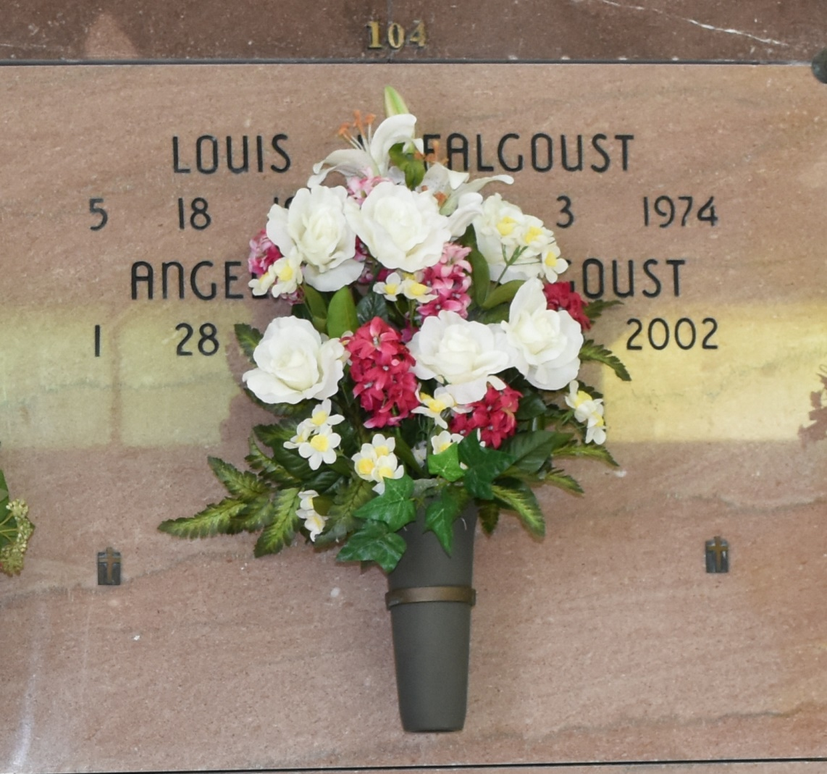

Angelina "Taunt Na Na" Chenier Falgoust, 88, a native and resident of Vacherie, died Thursday, Dec. 5, 2002.

Visitation will be from 9 a.m. to funeral time today at Our Lady of Peace Catholic Church in Vacherie. Mass will be at noon today at the church, with burial in the church cemetery.

She is survived by numerous nieces, nephews and relatives.

She was preceded in death by her husband, Louis Falgoust; her parents, Augusta Oubre Chenier and Amadeus Chenier; two brothers, Elphege and Antoine; and five sisters, Aggie, Emma, Odile, Irma and Antonitte.

Houmatoday.com

December 6, 2002