Annette Eve “Nettie” Falgoust

August 26, 1950 – October 12, 2015

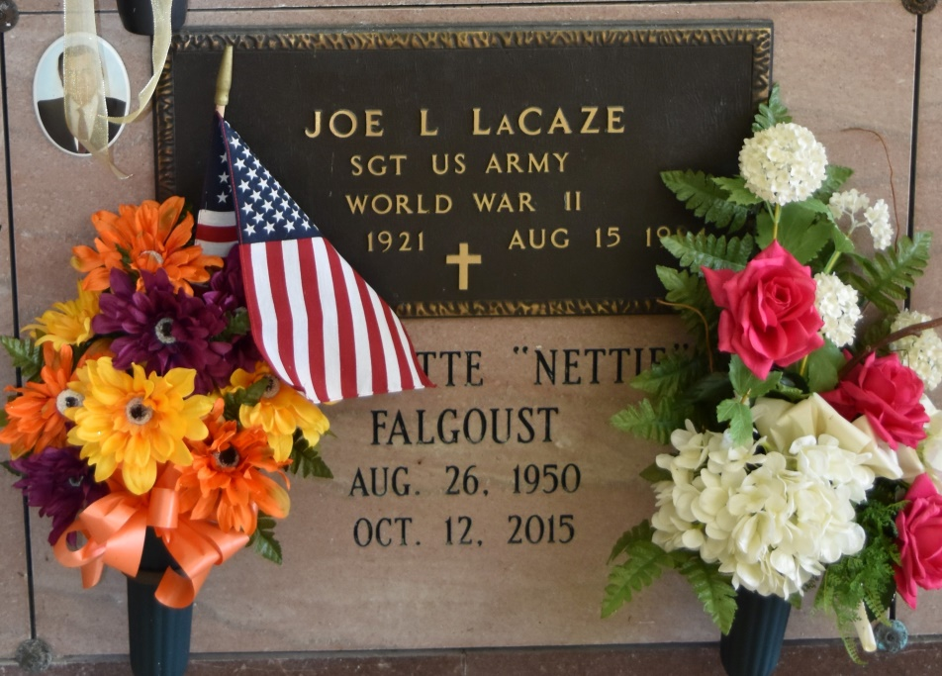

Antoinette Eve "Nettie" Falgoust, 65, a native of Vacherie and resident of Thibodaux, passed away on Monday, October 12, 2015.  
 Visitation will be held on Saturday, October 17, 2015 at 9:00 a.m. until Mass of Christian Burial at 11:00 a.m. at Our Lady of Peace Catholic Church in Vacherie. Entombment to follow in the church mausoleum. Arrangements made by Ourso Funeral Home in Donaldsonville.  
 She is survived by her mother, Olive G. Falgoust Stevenson; one sister, Patty Falgoust Abadie; one niece, Tessa Abadie Faucheux and husband, Benjamin; one nephew, Byron Abadie and wife, Heather; four great nephews, Nathan and Nicholas Abadie, Luke and James Faucheux; and her extended family at Diplomat Way in Thibodaux.  
 She was preceded in death by her father, Robert J. Falgoust; grandparents, Mark and Antoinette Granier and Bienvenue and Laura Falgoust.  
 Pallbearers will be Byron Abadie, Ben Faucheux, Horace "Butch" Granier, Martin Granier, Gerald Rome, and Mike Falgoust. Honorary Pallbearers will be Kevin Tregre, J.B. Falgoust, and Donald Rome.  
 In lieu of flowers, family requests donations be made to Diplomat Way Community Home, 208 Diplomat Way, Thibodaux, La 70301.  
 To offer condolences to the family, please sign online guestbook at [www.oursodonaldsonville.com.](http://www.oursodonaldsonville.com/)

Houma Today, Terrebonne Parish, LA

Oct. 14 to Oct. 15, 2015