Daisy Marie (Labat) Falgoust

March 4, 1921 – January 14, 2012

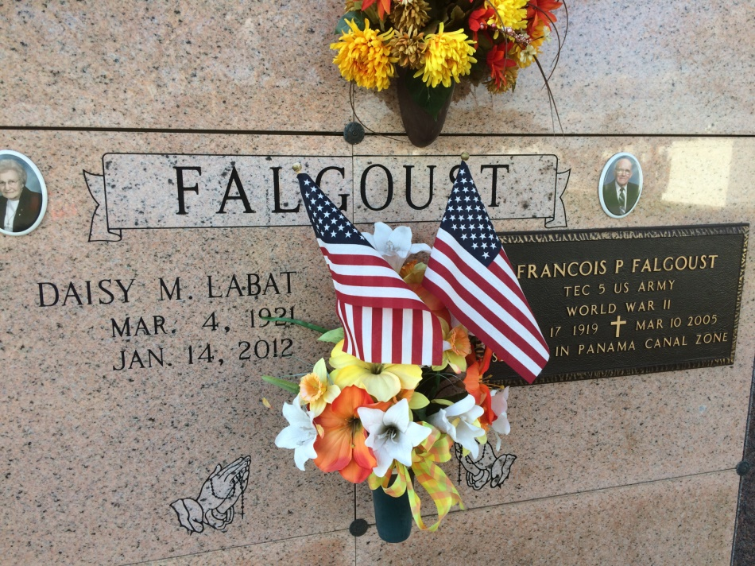

Photo by Kerry Keller

Daisy Labat Falgoust, 90, a native and resident of Vacherie, died Saturday, Jan. 14, 2012, in Vacherie. She was born on March 4, 1921. Visitation will be at Our Lady of Peace Catholic Church in Vacherie on Monday, Jan. 16, from 8 a.m. until Mass of Christian Burial at 11 a.m., with the Rev. Michael Miceli, celebrant. Entombment to follow in the church mausoleum. She is survived by two sons, Gerald J. Falgoust and wife Judy, and Francis P. Falgoust, all of Vacherie; two sisters, Ella "Lal" Buquoi, of Baton Rouge, and Aline Folse, of Vacherie; brother, Edmond "Tim'' Labat, of Baton Rouge; five grandchildren, Mark Falgoust and wife Cathy, of Houma, Gregory Falgoust, of Baton Rouge, Carmen Blouin and husband Shane, and Dawn Talbot and husband Cory, all of Thibodaux, and Chad Falgoust and fiancée Heather, of Prairieville; and seven great-grandchildren. She was preceded in death by her first husband, Joseph Landreaux Falgoust, killed in action in World World II; second husband of 55 years, Francois P. "Frank" Falgoust, on March 10, 2005; parents, Louis E. and Anita Oubre Labat; three brothers, Willie "Bill" Labat, Nelson Labat and Edward Labat; sister, Marie "Nin" Schexnayder; an infant sister; and two grandsons, Gerald Falgoust Jr. and Mathew P. Falgoust. The family would like to thank Journey Hospice nurses Grace and Felecia, nurse's aide, Nettie, Deacon Brent, Dr. Chester Boudreaux, Dr. Robert Greer and our caregivers, Gracie Dumas, Mary Reulet, Arleen Tregre and Debra Rodrigue for their loving care. Please sign the online guestbook at www.landrysfuneralhome.com. Arrangements by Landry's Funeral Home, Thibodaux.

Advocate, The (Baton Rouge, LA) - Sunday, January 15, 2012

Contributed by Jane Edson