Eddie J. Falgoust

April 21, 1909 – March 30, 2000

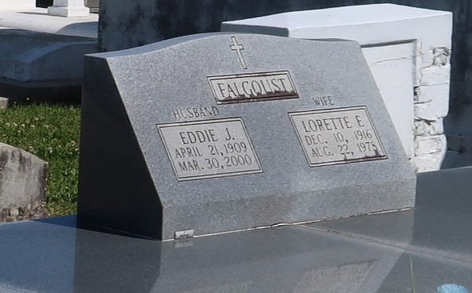

A resident and native of Vacherie, he died Thursday, March 30, 2000. He was 90, born April 21, 1909. Visitation at Our Lady of Peace Catholic Church, Vacherie, from 9 a.m. until Mass of Christian Burial at 11 a.m. Saturday. Interment in the church cemetery. Survived by three sons, Francis and Jerry Falgoust, both of Vacherie, and Raymond Falgoust, Kenner; a daughter, Mrs. E.J. (Marie Louise) Rose, Vacherie; a half-brother, Rodney Falgoust, LaPlace; three sisters, Kathleen Waddell, Metairie, Annette Gauthreaux and Ina Claire Falgoust, both of Vacherie; 12 grandchildren; and numerous great-grandchildren. Preceded in death by his parents, Placide and Marie Rome Falgoust; three brothers, Placide Jr., Lynn and Elmo Falgoust; and a half-sister, Therese Falgoust. Thibodaux Funeral Home Inc., Thibodaux, in charge of arrangements.

Advocate, The (Baton Rouge, LA) - Saturday, April 1, 2000  
Contributed by Jane Edson