Evelina (Schexnayder) Falgoust

November 8, 1912 – January 4, 1997

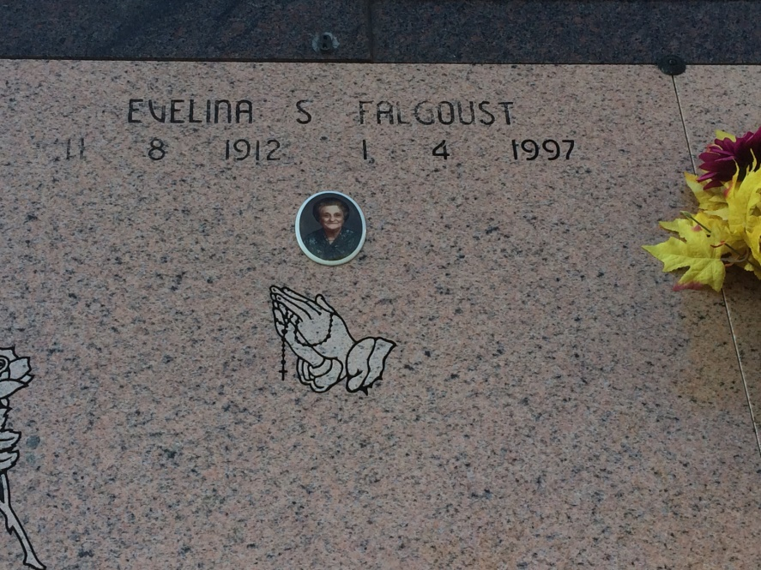

Photo by Kerry Keller

Evelina S. Falgoust, 84, a native and resident of Vacherie, died at 6:15 a.m. Saturday, Jan. 4, 1997.  
 Visitation will be from 7:30 a.m. to funeral time Monday at Our Lady of Peace Church, Vacherie. Mass will at 10 a.m. at the church, with burial in the church cemetery.  
 She is survived by two daughters, Kenneth "Mae" Hymel and Rosalind "Ralph" Zeringue; one brother, Ernest Schexnayder; four sisters, Elodie Falgoust, Cecile Brazan, Blanche Oncale and Agnes Kraemer; seven grandchildren; and 10 great-grandchildren.  
 She was preceded in death by her husband, Lloyd J. Falgoust; her parents,Aurelien an Evelie Becnel Schexnayder; two brothers, Denis and Fernand Schexnayder; and one greatgrandchild.

Unknown source

Contributed by Wayne Oncale