Francois Paul Falgoust

December 17, 1919 – March 10, 2005

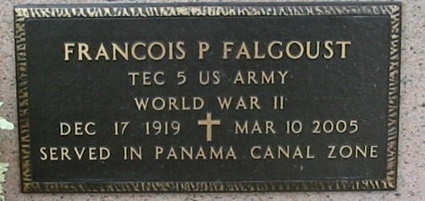

Photo by Bobby

Francois 'Frank' Paul Falgoust, age 85. Born December 17, 1919. Died on Thursday, March 10, 2005 at 8:15 a.m. A native and resident of Vacherie, LA. Survived by his wife Daisy Labat Falgoust; 2 sons: Gerald and Francis Falgoust and 1 brother, J.B. Falgoust. Also survived by 6 Grandchildren and 6 Great Grandchildren. Preceded in death by his parents Bienvenue and Laura Becnel Falgoust; 5 brothers: Leonard, Sr., Bruce, Lloyd, Fred and Robert Falgoust; 2 sisters: Laura Rome and Amelia Rome.  
  
Visitation 8:00 a.m. until funeral time on Saturday March 12, 2005 at Our Lady of Peace in Vacherie, LA. Mass of Chrisitan burial Saturday, March 12, 2005 at 11 a.m. Our Lady of Peace in Vacherie, LA. Interment Our Lady of Peace in Vacherie, LA.  
  
LANDRY'S FUNERAL HOME, INC. IN CHARGE OF ARRANGEMENTS

Times-Picayune, The (New Orleans, LA) - Friday, March 11, 2005

Contributed by Jane Edson