Freddy Joseph Falgoust Sr.

June 21, 1917 – Mary 13, 2004

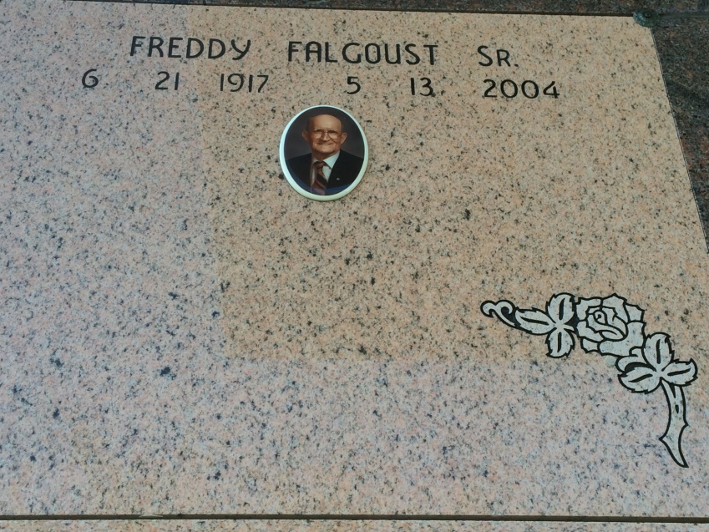

Photo by Kerry Keller

VACHERIE - Freddy J. Falgoust Sr., 86, a native and resident of Vacherie, died May 13. He was the husband of the late Elodie Schexnayder Falgoust, and father of Edna Folse, Evelie Gravois and Freddy Falgoust Jr.  
  
He was also the son of the late Bienvenue and Laura Falgoust, and brother of Frank and J.B. Falgoust., and the late Laura Rome, Amelie Rome, Bruce, Lloyd, Leonard and Robert Falgoust.  
  
He is also survived by seven grandchildren and eight great-grandchildren.  
  
Services are today at 11 a.m. at Our Lady of Peace Catholic Church, South Vacherie, with interment at the church cemetery. Visitation starts at 8 a.m.

L'Observateur (La Place, LA) - Friday, May 14, 2004

Contributed by Jane Edson