Mabel (Bourgouis) Falgoust

May 4, 1920 – April 5, 2009

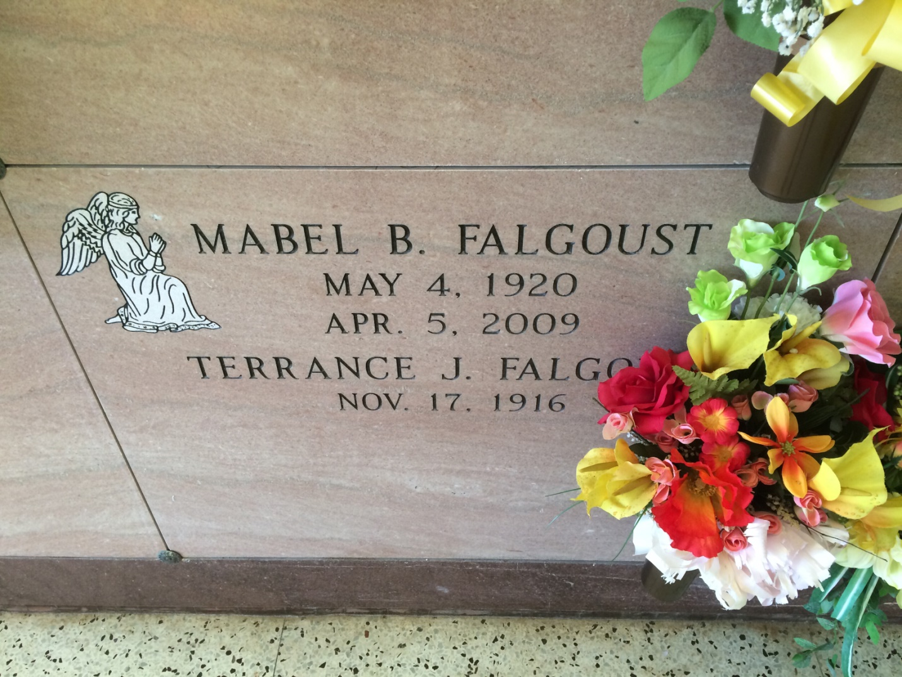

Photo by Kerry Keller

Mabel Bourgouis Falgoust, age 88, born on May 4, 1920, died on April 5, 2009 at 4:33 AM. She was a resident and native of Vacherie, LA. Survived by husband married for 68 years; 3 sons, 1 daughter, 10 grandchildren and 15 great-grandchildren. Preceded in death by parents, Sidney Bourgouis and Genevieve Reulet Bourgouis; 2 daughters-in-law, Betty R. Falgoust and Rebecca T. Falgoust; 2 brothers, Neil and John Bourgouis; and 2 sisters, Rete B. Hymel and Angel B. Weber. Visitation from 8 AM until 11 AM on Tuesday, April 7, 2009 at Our Lady of Peace, Vacherie, LA. Funeral Services at 11 AM on Tuesday, April 7, 2009 at Our Lady of Peace, Vacherie, LA. Interment Our Lady of Peace, Vacherie, LA. Thibodaux Funeral Home, Inc., Thibodaux, LA, in charge of arrangements.

Unknown source