Marie Therese (Rome) Falgoust

June 27, 1936 – February 4, 2010

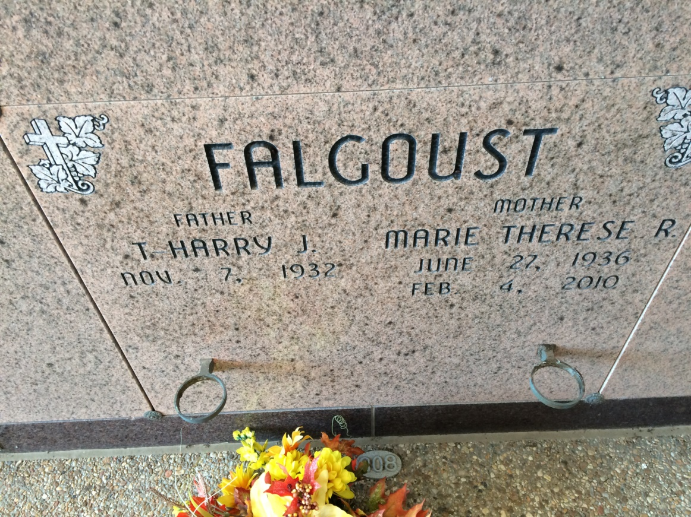

Photo by Kerry Keller

Marie Therese Falgoust, 73, a native and resident of Vacherie, died Thursday, Feb. 4, 2010.  
 Visitation will be from 8 a.m. to funeral time today at Our Lady of Peace in Vacherie. Mass will be 10:30 a.m. today at the church, with burial in the church cemetery.  
 She is survived by her husband of 57 years, T-Harry Falgoust; one son, Curtis Falgoust and wife, Pam; one daughter, Kathy F. Oubre and husband, Howard; one son-in-law, David Troxler; one sister, Ruth Becnel; eight grandchildren; and seven great-grandchildren.  
 She was preceded in death by her parents, Joseph "Vic" Victorin Rome and Marie Althe Becnel Rome; one daughter, Connie F. Troxler; one brother, V.J. Rome; and one sister, Margaret Rome Cortez.  
 Thibodaux Funeral Home is in charge of arrangements.

Unknown source