Mathew Paul Falgoust

November 7, 1984 – January 14, 2007

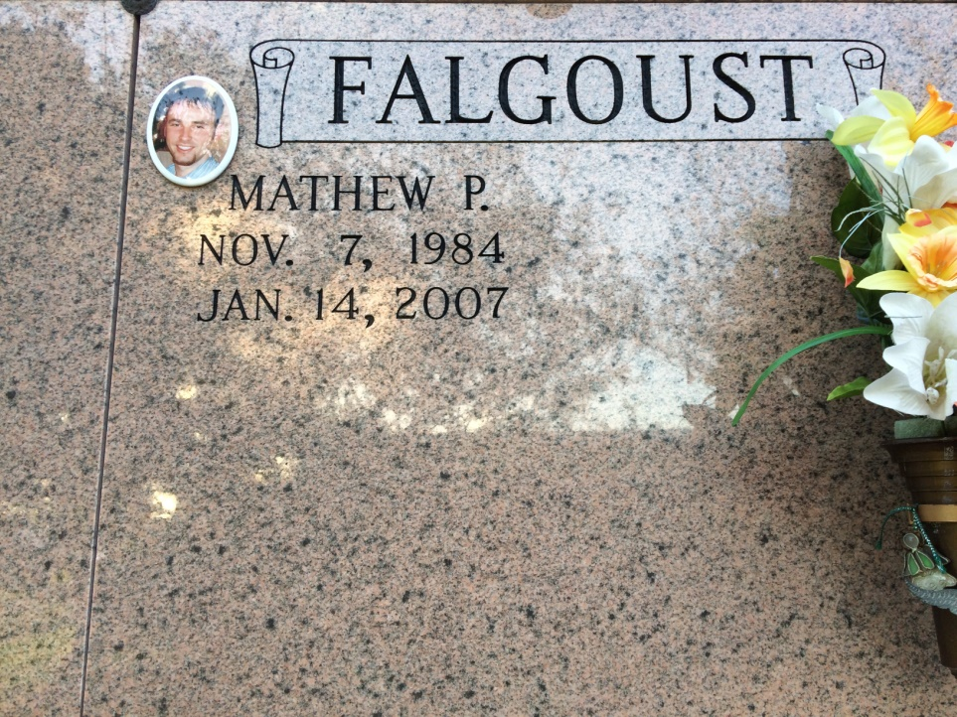

Photo by Kerry Keller

Mathew Paul Falgoust, a resident and native of Vacherie, died Sunday, Jan. 14, 2007. He was 22, born Nov. 7, 1984. Visitation at Our Lady of Peace Catholic Church in Vacherie on Thursday, Jan. 18, from 8 a.m. until Mass of Christian Burial at 11 a.m. Interment in the church cemetery. He is survived by his father, Francis Paul Falgoust; mother and stepfather, Linda Becnel and Kenny Peterson; grandparents, Daisy L. Falgoust and Patrick and Betty Becnel; brother and stepbrother, Chad Falgoust and Brandon Peterson; sister, Dawn Falgoust; and stepsister, Brandy Villalta. He was preceded in death by grandparent, Francois P. Falgoust. He was a 2003 graduate of E.D. White Catholic High School, Thibodaux, a 2004 graduate of Universal Technical Institute of Houston and an employee of All-Star Hyundai. Arrangements by Landry's Funeral Home Inc., Thibodaux.

Advocate, The (Baton Rouge, LA) - Wednesday, January 17, 2007

Contributed by Jane Edson