Nazaire Joseph Falgoust Jr.

July 4, 1914 – November 16, 2009

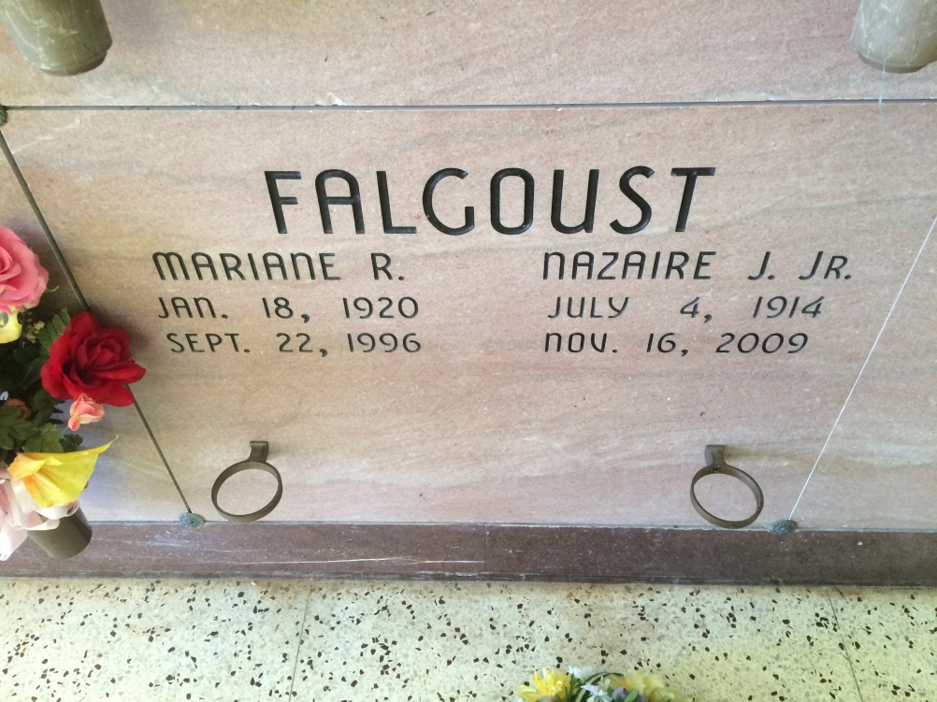

Photo by Kerry Keller

Nazaire "T-Naz" Falgoust, Jr., age 95, born July 4, 1914, passed away on Monday, November 16, 2009. A native and resident of Vacherie, LA. Survived by 4 sons: Calvin, Stephen, Eugene and Randy Falgoust; 3 daughters: Margie Rodrigue, Linda Boudreaux and Amanda Scioneaux; brothers: Percy and Harry Falgoust; sisters: Naomi, "T-Min" Labat and Rita Templet; 19 grandchildren, 41 great-grandchildren; and 3 great-great-grandchildren. Preceded in death by: wife, Marianne Rodrigue Falgoust; parents: Nazaire Falgoust, Sr. and Estelle Dempster Falgoust; brother, Pershin Falgoust; sisters: Olina Folse and infant Oline Falgoust; granddaughter, Pamela Montano; and sons-in-law: Carrol Boudreaux and Raymond Scioneaux, Sr.  
 Visitation 8:00 a.m. until funeral time on Wednesday, November 18, 2009 at Our lady of Peace Catholic Church, Vacherie, LA. Mass of Christian Burial at 11:00 a.m. on Wednesday at Our Lady of Peace Church in Vacherie. Interment Our Lady of Peace Cemetery, Vacherie, LA.  
 Thibodaux Funeral Home, Inc., Thibodaux, LA in charge of arrangements.

Times-Picayune, The (New Orleans, LA) - Tuesday, November 17, 2009

Contributed by Jane Edson