Reasa Jean (Rodrigue) Falgoust

January 9, 1967 – January 22, 2018

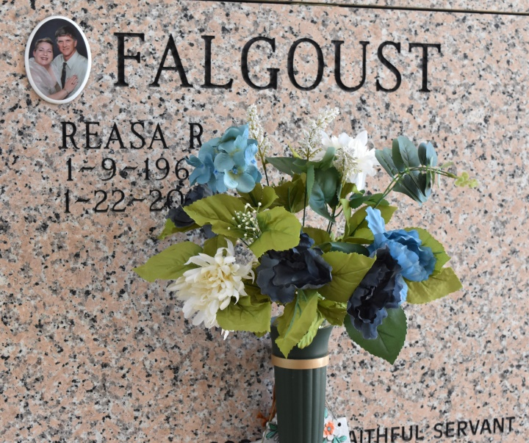

Reasa Jean Rodrigue Falgoust was entrusted to God's loving care on Monday, Jan. 22, 2018. She was a native and resident of Vacherie. A Visitation will be held at Our Lady of Peace Catholic Church on Wednesday, Jan. 24, 2018 from7:30 a.m. until funeral time. A Mass of Christian Burial will take place at 11 a.m. Interment will follow in the church cemetery. She is survived by her husband, Eric Falgoust; son, Shelby Lassere; daughter, Hailey Lassere and fiancé, Howard Jean Kraemer III; parents, Leslie and Antoinette Rodrigue; sister, Antoinette "Toni" Rodrigue and fiancé, Kevin Olinde; godchildren, Paul Harang, Brandon Rodrigue and Drue Polkey; niece, Fallon R. Terracina; and numerous nieces and nephews. She was preceded in death by her brother, Cyril P. Rodrigue. Reasa was a devoted wife, mother, sister, daughter and friend. She always put everyone before herself, always trying to assist with other's burdens even with the weight of her own. She will be greatly missed by everyone who knew her. Thibodaux Funeral Home Inc. is in charge of arrangements.

Houma Today & The Daily Comet (LA)

Jan. 22 to Jan. 23, 2018