Robert Joseph Falgoust

November 3, 1906 – February 24, 2002

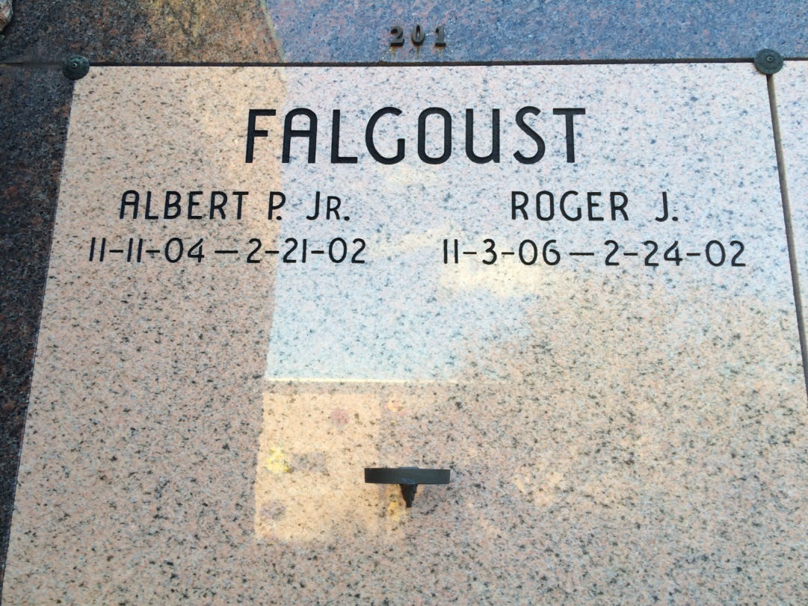

Photo by Kerry Keller

ST. JAMES - Roger Joseph Falgoust, 95, a native of Vacherie and resident of St. James, died Feb. 24. He was the son of the late Albert Sr. and Emilda Rome Falgoust and brother of the late Louise LaFranz, Helen and Victor Rome and Christine, Adelta, Laura, Roger and the late Albert Falgoust Jr.  
  
Joint services were Feb. 26 at St. James Catholic Church, St. James, with interment at the Our Lady of Peace Mausoleum, Vacherie.

L'Observateur (La Place, LA) - Thursday, February 28, 2002

Contributed by Jane Edson