Russell J. Falgoust

March 18, 1938 – August 30, 2021

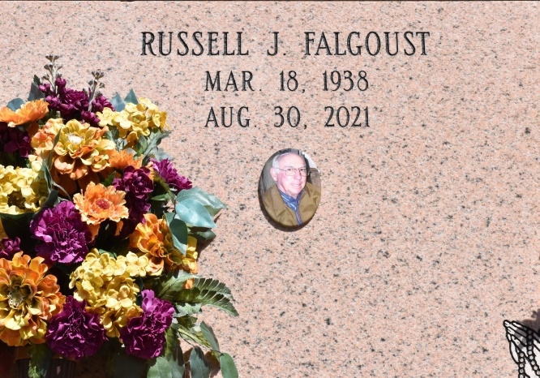

Vacherie - Russell J. Falgoust, a native and resident of Vacherie, LA, was born on March 18, 1938, and passed away peacefully on August 30, 2021 at the age of 83.

He is survived by his sister, Lena Mae Kliebert; sister-in-law, Gail Weble Falgoust; Godchildren, Myra Falgoust Simon, Joy Kliebert Labat, and James Falgoust, Jr.; and several nieces and nephews.

He was preceded in death by his parents, Leonard Sr. and Marceline Rome Falgoust; brother, Leonard Jr. and wife Velma Dempster Falgoust; sister, Nell Falgoust and husband Roland Amedee; and brother, James Falgoust, Sr.

With over twenty years of educating children completed, he enjoyed spending time in nature hunting. When not in the woods, he was tending to his beagles, his fruit trees, or driving the roads of Vacherie visiting the community members he considered family. He will be dearly missed.

A visitation was held at Thibodaux Funeral Home on Friday, September 3, 2021 from 8:30 - 9:30AM followed by a Mass of Christian Burial at 9:30AM. He was laid to rest in Our Lady of Peace Cemetery in Vacherie, LA.

Online condolences can be given at [www.thibodauxfuneralhome.com](https://www.thibodauxfuneralhome.com/)

Thibodaux Funeral Home, Inc. is in charge of arrangements.

Houmatoday.com; Posted online on October 02, 2021

Published in Daily Comet, Houma Daily Courier (LA)