Terrance Joseph Falgoust

November 17, 1916 – July 29, 2016

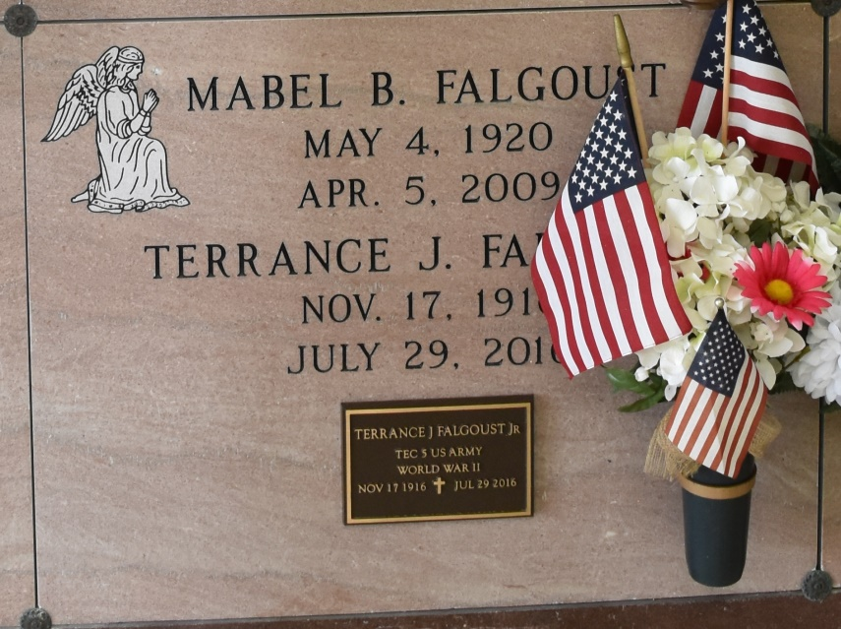

Terrance Joseph Falgoust, 99, a native and resident of Vacherie, Louisiana passed away on July 29, 2016.  
 A visitation will be held in his honor on Tuesday, August 2 at Our Lady of Peace Church, Vacherie, LA from 7:30 a.m. until the Funeral Service at 11:00 a.m. The burial will follow in Our Lady of Peace Cemetery in Vacherie, LA.  
 He is survived by his three sons, Terry Falgoust, Kenneth Falgoust, Eric Falgoust and wife, Reasa; daughter, Cynthia Falgoust; ten grandchildren, Melissa Alleman, Terry Falgoust, Jr., Chris Falgoust, Jeremy Cortez, Wesley Cortez, Joshua Falgoust, Jessica Bruno, Cody Falgoust, Dustin Falgoust, and Hunter Falgoust; and seventeen great-grandchildren.  
 He was preceded in death by his wife, Mabel B. Falgoust; two sisters, Ida Lasserre and Genevieve Zatarian; three brothers, Edmond Falgoust, Oneil Falgoust, Lynn Falgoust; and two daughters-in-law, Betty Falgoust and Rebecca Falgoust.  
 Thibodaux Funeral Home, Inc. is in charge of arrangements.

Houma Today, Terrebonne Parish, LA

Jul. 30 to Aug. 1, 2016