Florence Fefie

July 28, 1936 – July 11, 1997

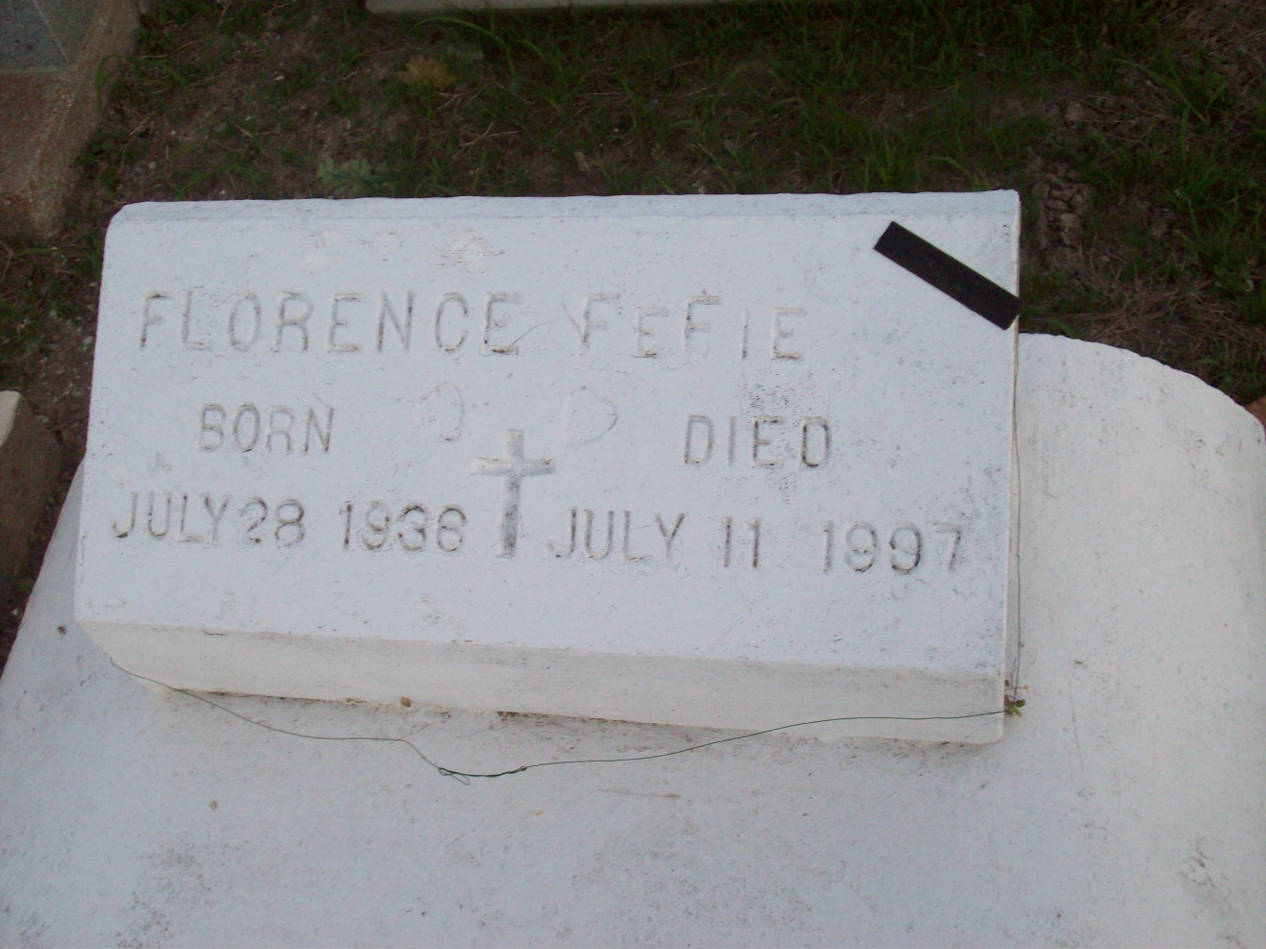

Photo by TMB

Florence Fefie was a resident of St. James, she died Friday, July 11, 1997, at Prevost Hospital, Donaldsonville. She was 61. Survived by four brothers, Alonzo Fefie, St. James, Cornelius Fefie, New Orleans, Paul Fefie, Houston, and Cuby Fefie, Los Angeles; friends, including Albert Smith and Nicole Joseph, both of St. James; three godchildren, Patricia Dennis and Carolyn Nicholas-Landry, both of St. James, and Bridget Silby, Westwego; three sisters-in-law, nieces, nephews, cousins and other relatives. Preceded in death by parents, Caroline Osborne and Cornelius Fefie; two sisters, Rosemary Fefie-Mack and Victorine Fefie-Geason; two brothers, Eugene and Horace Fefie; and a sister-in-law. She was a member of Pride of Brookstown Society.

Unknown source