Harold Joseph Folse

October 27, 1930 – September 10, 1998

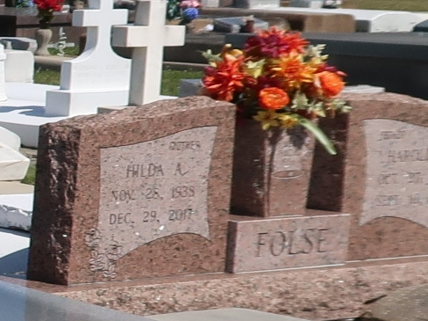

Harold Joseph Folse, 67, a native and resident of Vacherie, died at 5:25,  
a.m. Thursday, Sept. 10. 1998.  
 Visitation will be from 8 a.m. until funeral time today at Our Lady of  
Peace. Mass will be at 10 a.m. at the church, with burial in the church  
cemetery.  
 He is survived by his wife, Hilda Amedee of Vacherie; two sons, four  
daughters; two brothers, four sisters, and 11 grandchildren.  
 He was preceded in death by his parents, Elphege and Odile Steib Folse;  
one son, Charles Folse; one daughter, Anne Folse; and one brother, Landreau Folse.

Unknown source