Hilda Jane (Amedee) Folse

November 28, 1938 – December 29, 2017

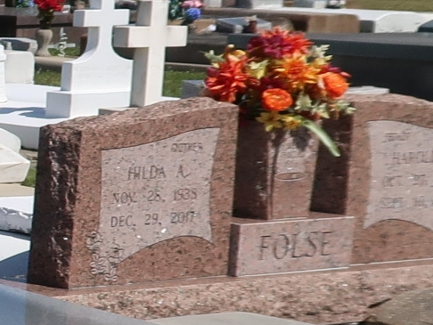

Hilda Amedee Folse, a native and resident of Vacherie, passed away on Friday, December 29, 2017 at the age of 79. Hilda leaves behind to cherish her memory four daughters, Trunell Landry (Ricky), Denise David (Peter), Thelma Cortez (Verdie), Rose Folse (Carroll); two sons, Eric Folse (Debbie) and Darrell Folse (Prudence); four sisters, Jan Borne, Mary Anne Folse, Rosie Delatte and Charlene Goan; four brothers, Nolan, Lonnie, Gary and Wayne Amedee; fourteen grandchildren and five great grandchildren. She is preceded in death by her husband, Harold J. Folse; two children, Charles Folse and Anne Folse; parents, Ives and Cecile Becnel Amedee and two brothers, Richard and Frankie Amedee. The family would like to thank Fresenius Dialysis Center and Notre Dame Hospice. Visitation be observed on Tuesday, January 2, 2018 from 7:30am until Mass of Christian Burial at 11am at Our Lady of Peace Catholic Church in Vacherie with graveside following in the church cemetery. To offer condolences to the family, please sign the online guestbook at [www.oursodonaldsonville.com](http://www.oursodonaldsonville.com).

Ourso Funeral Home, Donaldsonville, LA

February 22, 2020