Alcee Freeman Jr.

August 15, 1923 – July 7, 1998

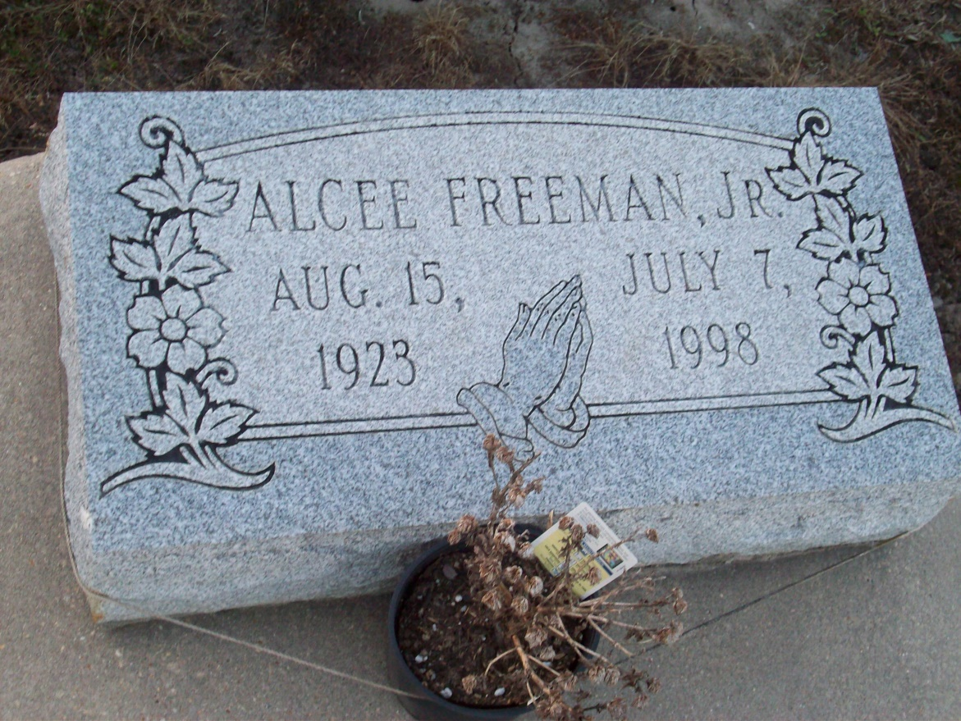

Photo by TMB

Alcee Freeman Jr. was the husband of Mary Jane Dumas Freeman; father of Ronald Freeman of Thibodaux, Albert Freeman of Marrero, Ernest Freeman of Vacherie, Mercedes Washington, of Avondale, Juanita Freeman of Waxahachie, Texas, Evelyn Freeman Oubre of Mesquite, Texas and Melanie Freeman Vedol of Vacherie; brother of Joseph Octave Freeman and Veronica Freeman Keller, both of Marrero, Julia Freeman Domino and Melanie Freeman Dumas, both of Vacherie.He is also survived by 15 grandchildren and nine great-grandchildren.He was preceded in death by his parents, Alcee Sr. and Melanie Steib Freeman;son, Alcee Freeman III; and sister, Agnes Freeman James. He was a member of the Good Children's Society of Vacherie.

Unknown source