Mary Jane (Dumas) Freeman

May 6, 1925 – October 28, 2009

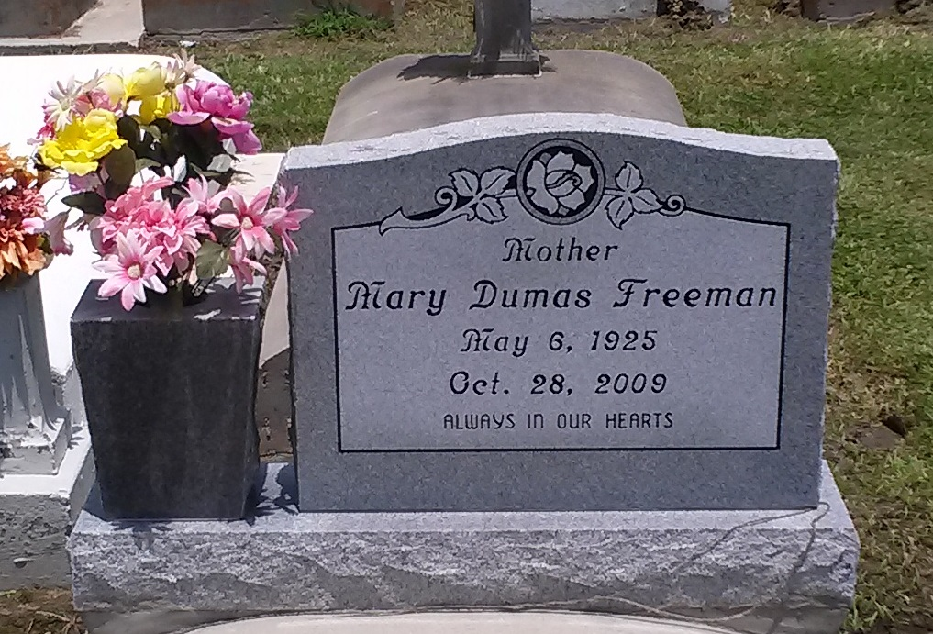

Photo by TMB

Mary Jane Dumas Freeman, 84, a native and resident of Vacherie, died Wednesday, Oct. 28, 2009. She is survived by her seven children, Melanie and husband, Kim Vedol, Evelyn and husband, Ivory Oubre, Juanita and husband, D’Wayne Bradford, Mercedes Washington, Ernest, Albert, and Ronald and wife, Marlise Freeman; three siblings, Celeste Dumas James, Russell and Anthony Dumas; 15 grandchildren; 12 great-great-grandchildren; two devoted god children and nieces; and a host of nieces, nephews, brothers and sisters in law, other relatives and friends. She was preceded in death by her husband, Alcee Freeman Jr.; one son, Alcee Freeman III; her parents, Paul B. and Rose Marie Osborne Dumas; and nine siblings, John, Harry, Whitney, Leo Paul and Hayward Dumas, Agnes Dumas Wooden, Victorine Dumas Simon and Wilborine Dumas Steib.

Unknown source