Dolter Marie (Keller) Gales

December 5, 1945 – August 29, 2020

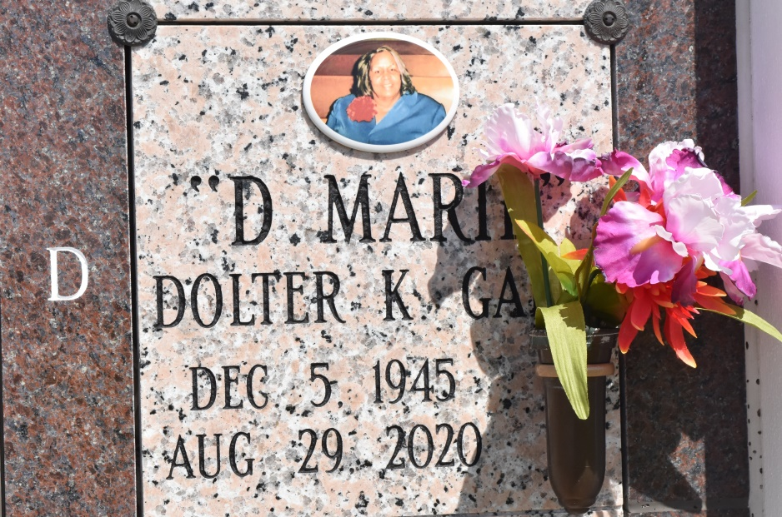

Dolter Marie Keller Gales departed this life on Saturday, August 29, 2020 at the age of 74. She is the former wife of Robert Gales; daughter of the late Julius Keller and Dolter Marie Dumas Keller; Loving mother of Donna Marie Keller Hedgepeth ( Raymond Hedgepeth) and Malord Nary Gales; Sister of Betty Jean Garibaldi, Prescott Francis Keller, Fabiola Ann Fleming and Adaline Mary Gales. She is also survived by 2 Granddaughters; Davonna Montegut and De'Jeuner Montegut, 8 Great grandchildren; Teon Jr., Josiah, Marielle, Ja'dore, Chase, Veah, Zhuri and Ermias, a loving companion the late Freddie De'Jean Jr. of 42 years, along with a host of nieces, nephews, other relatives friends and family. Relatives and friends of the family, also priest and parishioners of Our Lady of Peace Catholic Church are invited to attend a Memorial Mass at Our Lady of Peace Catholic Church, 13281 LA-644 Vacherie, LA. on Thursday September 10, 2020 at 11:00 am. Rosary and Reading will begin at 10:30 am. Interment will be private. Arrangements by D.W. Rhodes Funeral Home, 3933 Washington Avenue. Please visit [www.rhodesfuneral.com](http://www.rhodesfuneral.com/) to sign the guestbook.

The Times-Picayune (New Orleans, Louisiana

Sep. 5 to Sep. 10, 2020